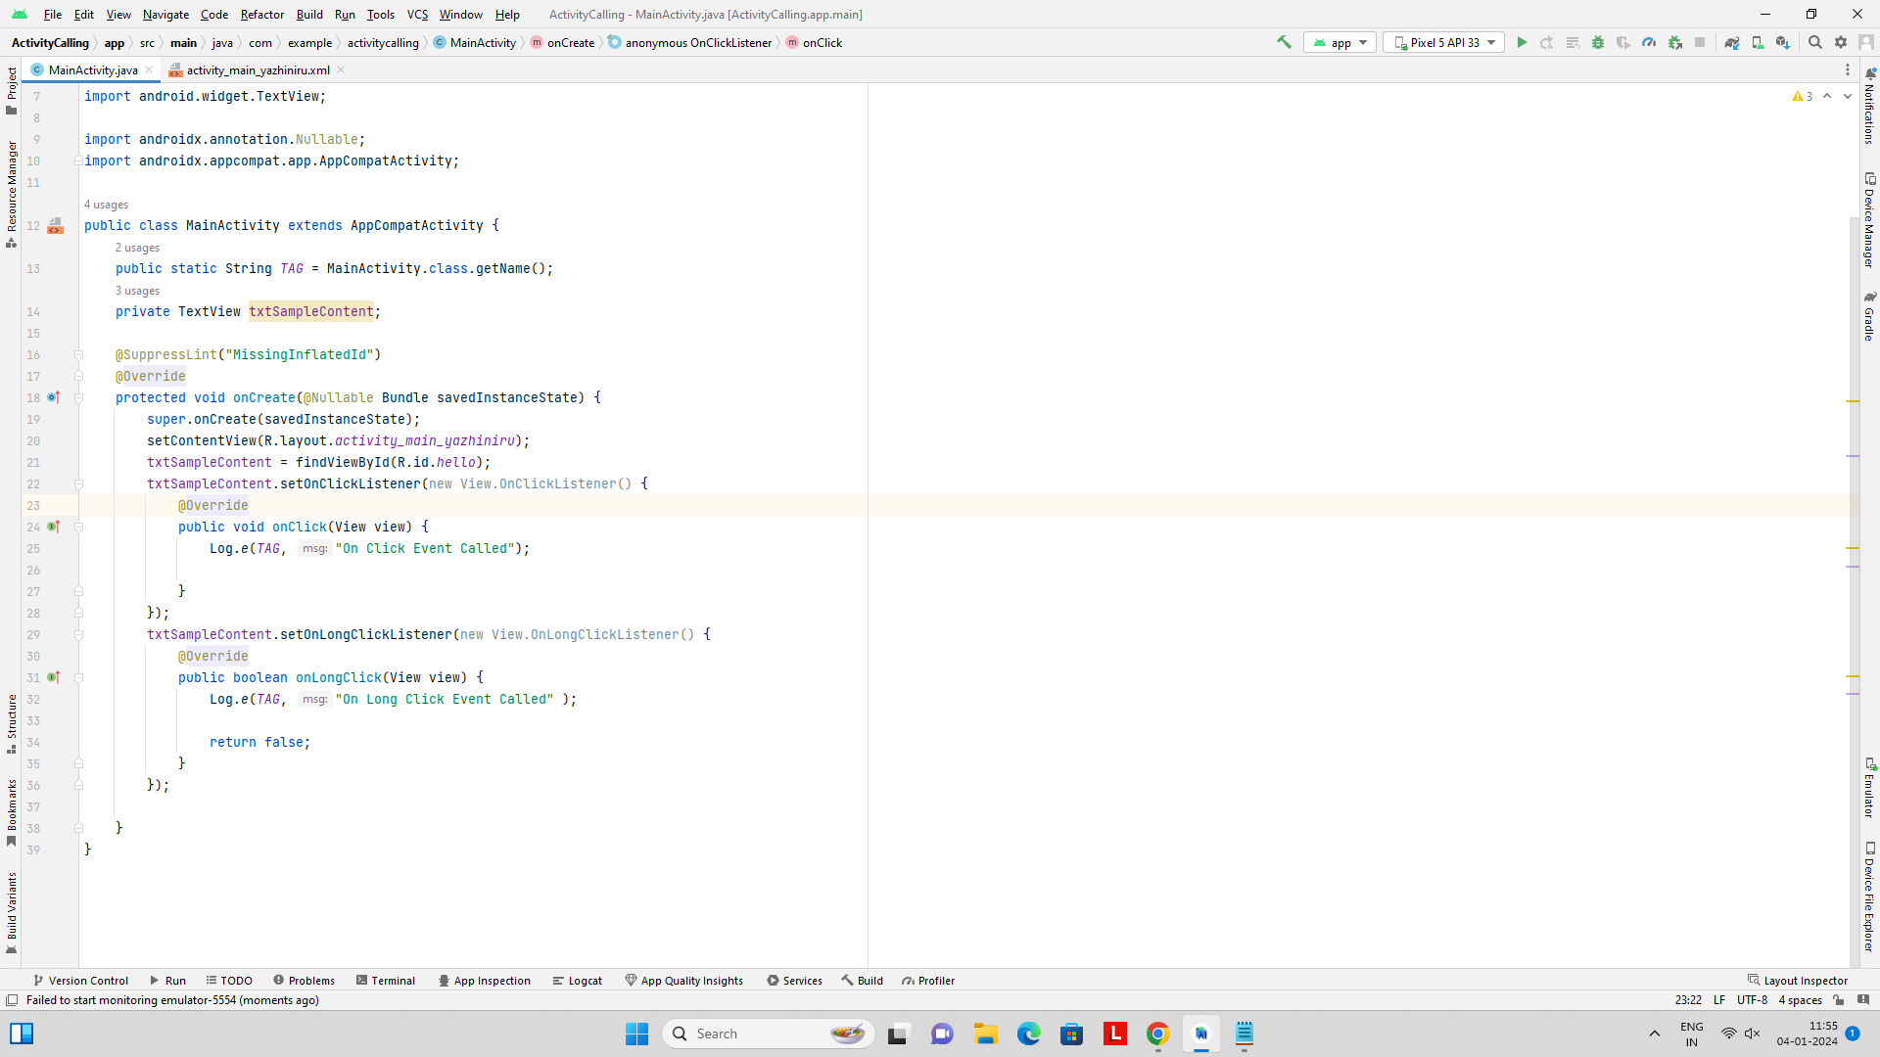

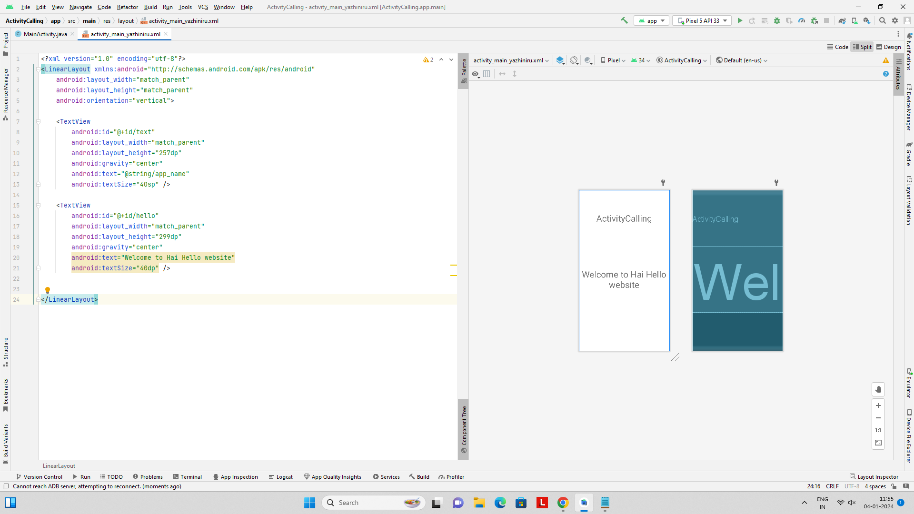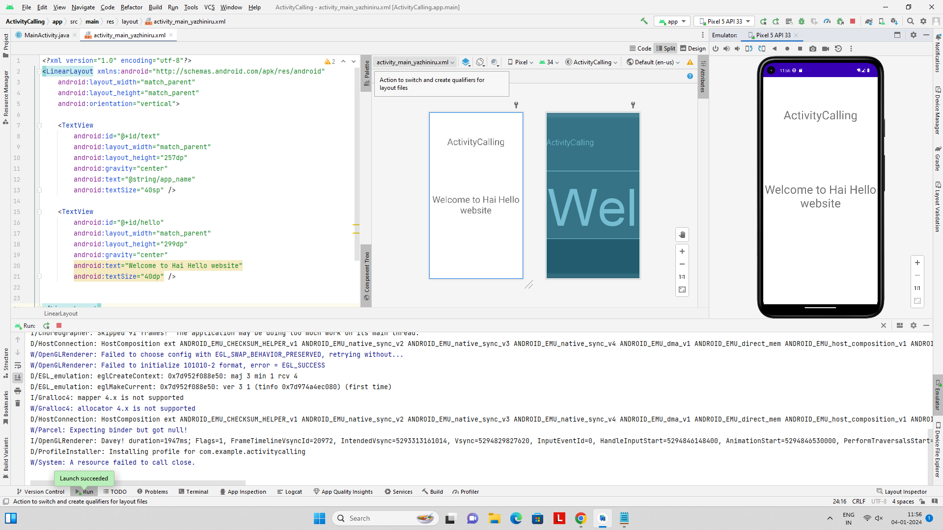

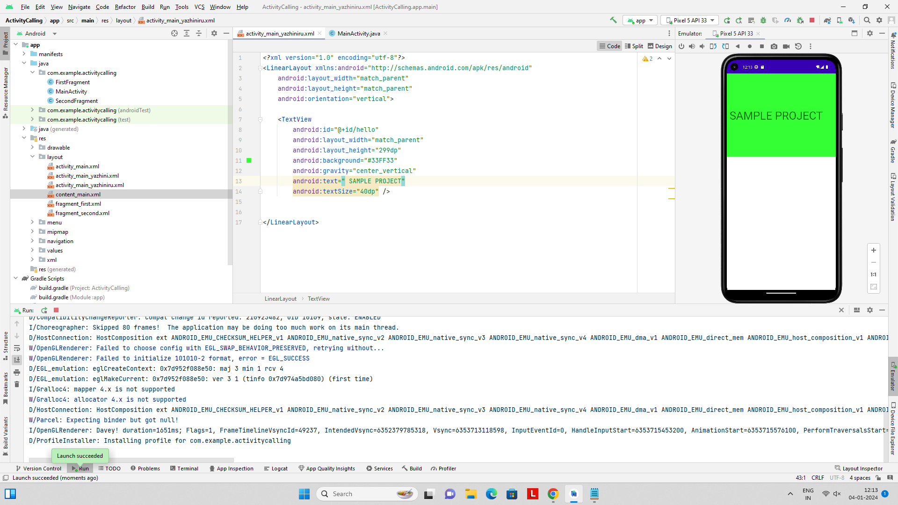

Calculator:

Java code

package com.example.myapplicationcalculator;

import android.os.Bundle;

import com.google.android.material.snackbar.Snackbar;

import androidx.appcompat.app.AppCompatActivity;

import android.view.View;

import androidx.navigation.NavController;

import androidx.navigation.Navigation;

import androidx.navigation.ui.AppBarConfiguration;

import androidx.navigation.ui.NavigationUI;

import com.example.myapplicationcalculator.databinding.ActivityMainBinding;

import android.view.Menu;

import android.view.MenuItem;

import android.widget.Button;

import android.widget.EditText;

import org.mariuszgromada.math.mxparser.Expression;

public class MainActivity extends AppCompatActivity {

private EditText editText;

@Override

protected void onCreate(Bundle savedInstanceState) {

super.onCreate(savedInstanceState);

setContentView(R.layout.*activity_main*);

editText = findViewById(R.id.*editText*);

}

public void onNumberClick(View view) {

Button button = (Button) view;

editText.append(button.getText());

}

public void onOperatorClick(View view) {

Button button = (Button) view;

editText.append(" " + button.getText() + " ");

}

public void onClearButtonClick(View view) {

editText.setText("");

}

public void onEqualButtonClick(View view) {

String expression = editText.getText().toString();

try {

Expression expr = new Expression(expression);

double result = expr.calculate();

editText.setText(Double.*toString*(result));

} catch (Exception e) {

editText.setText("Error");

}

}

}

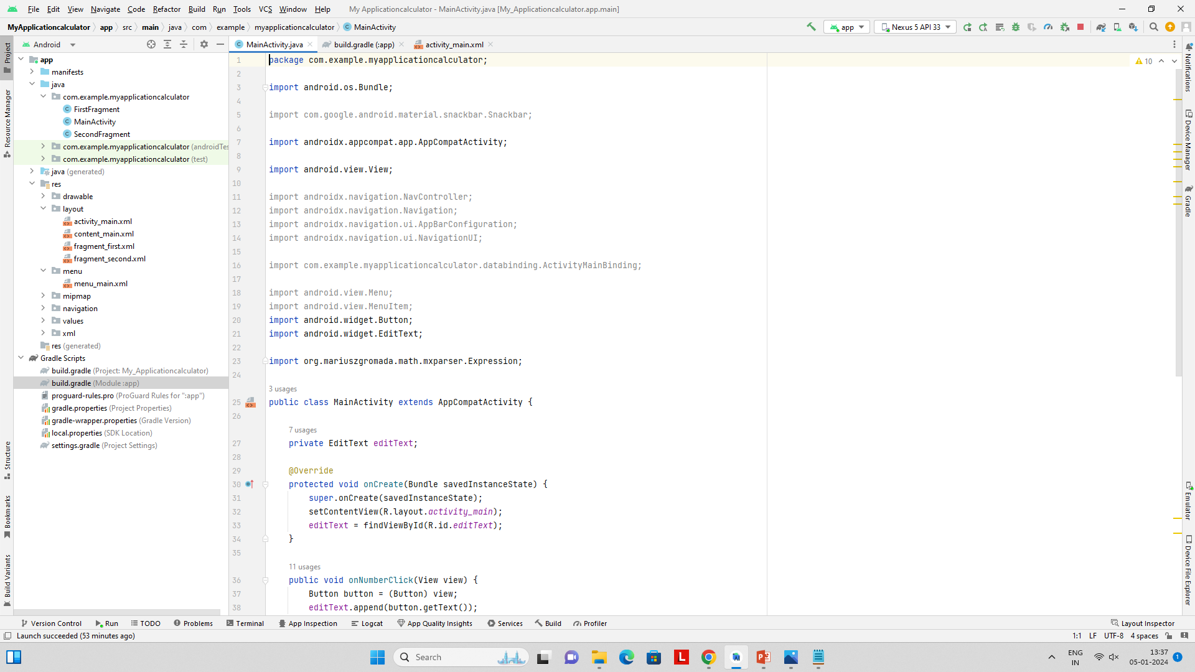

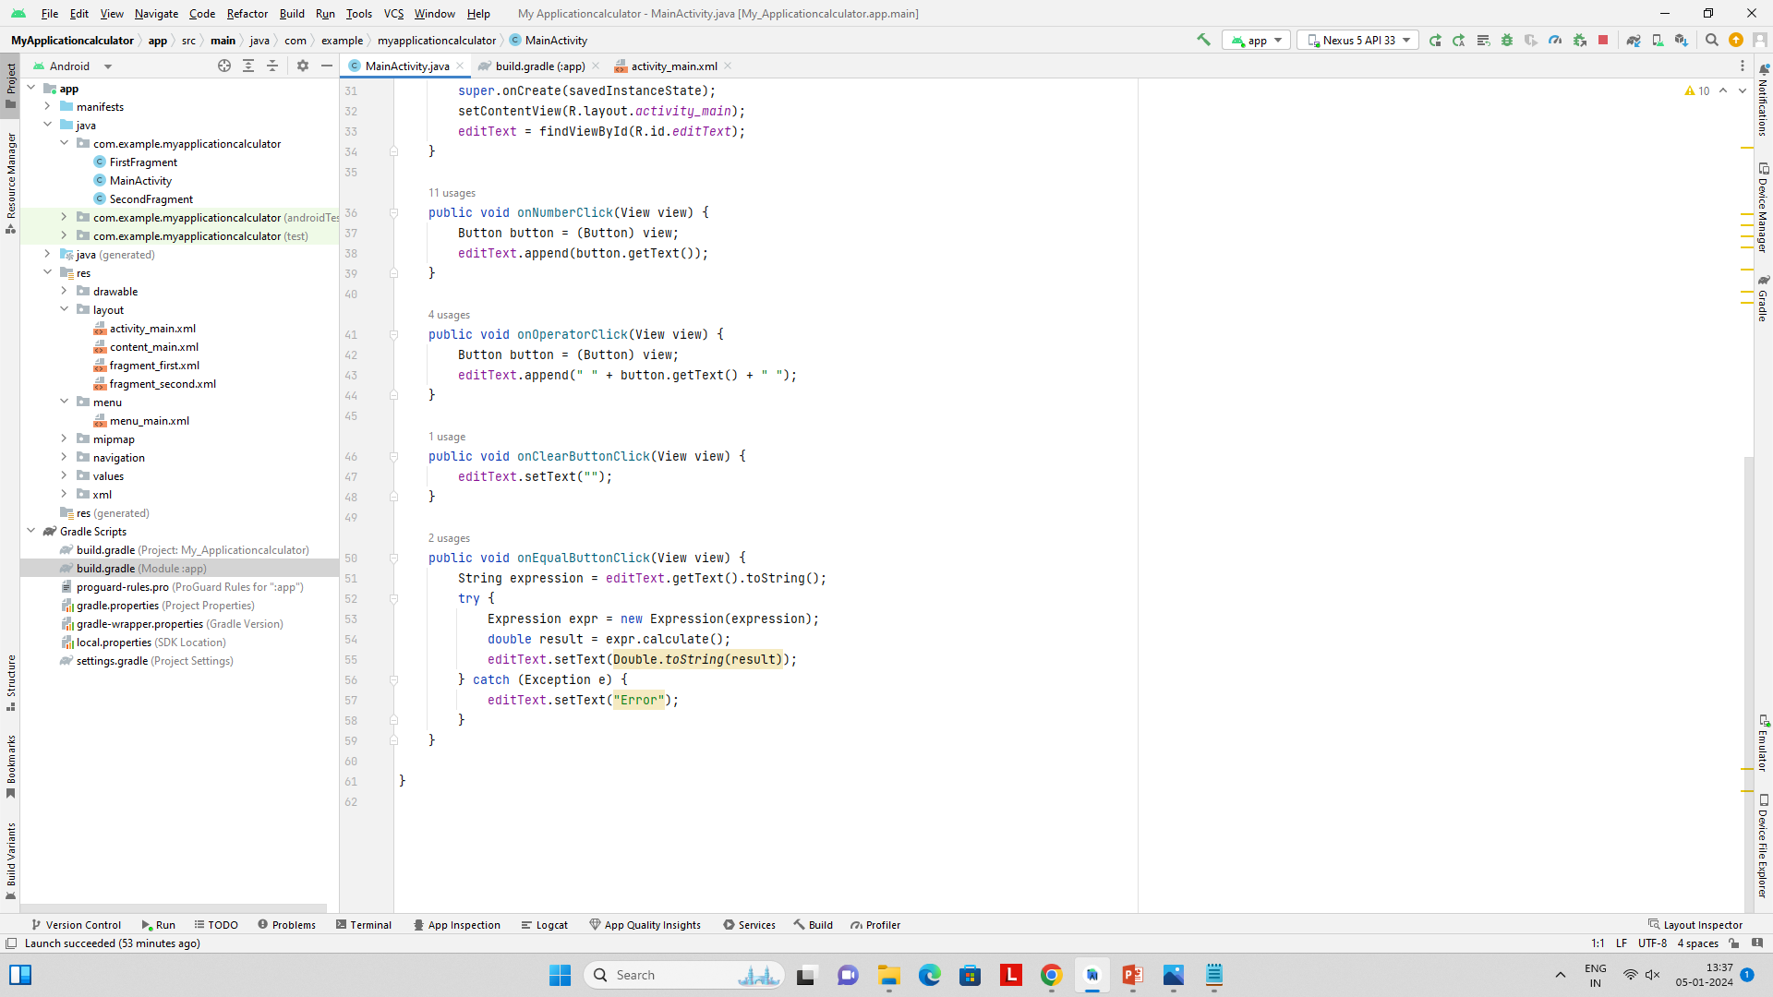

Xml code:

*<?*xml version="1.0" encoding="utf-8"*?>*

<LinearLayout xmlns:android="http://schemas.android.com/apk/res/android"

xmlns:tools="http://schemas.android.com/tools"

android:layout_width="match_parent"

android:layout_height="match_parent"

android:orientation="vertical"

android:padding="16dp"

tools:context=".MainActivity">

<EditText

android:id="@+id/editText"

android:layout_width="match_parent"

android:layout_height="wrap_content"

android:layout_marginBottom="16dp"

android:hint="0"

android:background="@color/teal_200"

android:inputType="text"

android:textSize="24dp" />

<GridLayout

android:layout_width="match_parent"

android:layout_height="wrap_content"

android:background="#808080"

android:columnCount="4"

android:rowCount="5">

*<!-- Buttons -->*

<Button

style="?android:attr/borderlessButtonStyle"

android:onClick="onClearButtonClick"

android:text="C" />

<Button

style="?android:attr/borderlessButtonStyle"

android:onClick="onOperatorClick"

android:text="/" />

<Button

style="?android:attr/borderlessButtonStyle"

android:onClick="onNumberClick"

android:text="7" />

<Button

style="?android:attr/borderlessButtonStyle"

android:onClick="onNumberClick"

android:text="8" />

<Button

style="?android:attr/borderlessButtonStyle"

android:onClick="onEqualButtonClick"

android:text="=" />

<Button

style="?android:attr/borderlessButtonStyle"

android:onClick="onNumberClick"

android:text="9" />

<Button

style="?android:attr/borderlessButtonStyle"

android:onClick="onOperatorClick"

android:text="*" />

<Button

style="?android:attr/borderlessButtonStyle"

android:onClick="onNumberClick"

android:text="4" />

<Button

style="?android:attr/borderlessButtonStyle"

android:onClick="onNumberClick"

android:text="5" />

<Button

style="?android:attr/borderlessButtonStyle"

android:onClick="onNumberClick"

android:text="6" />

<Button

style="?android:attr/borderlessButtonStyle"

android:onClick="onOperatorClick"

android:text="-" />

<Button

style="?android:attr/borderlessButtonStyle"

android:onClick="onNumberClick"

android:text="1" />

<Button

style="?android:attr/borderlessButtonStyle"

android:onClick="onNumberClick"

android:text="2" />

<Button

style="?android:attr/borderlessButtonStyle"

android:onClick="onNumberClick"

android:text="3" />

<Button

style="?android:attr/borderlessButtonStyle"

android:onClick="onOperatorClick"

android:text="+" />

<Button

style="?android:attr/borderlessButtonStyle"

android:onClick="onNumberClick"

android:text="0" />

<Button

style="?android:attr/borderlessButtonStyle"

android:onClick="onNumberClick"

android:text="." />

<Button

style="?android:attr/borderlessButtonStyle"

android:layout_columnSpan="2"

android:onClick="onEqualButtonClick"

android:text="=" />

</GridLayout>

</LinearLayout>

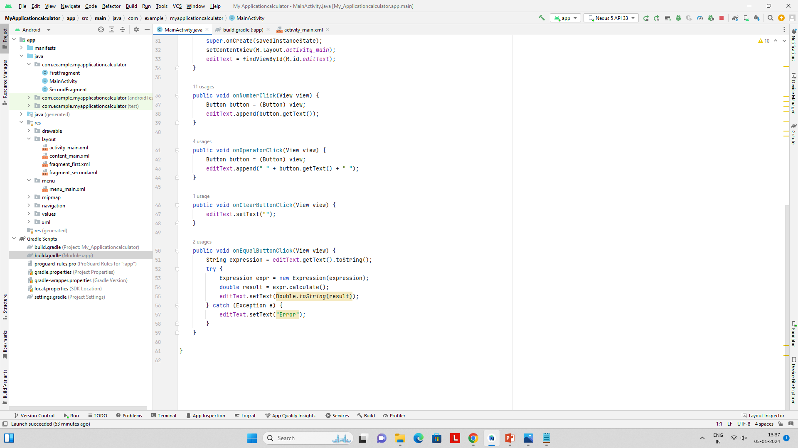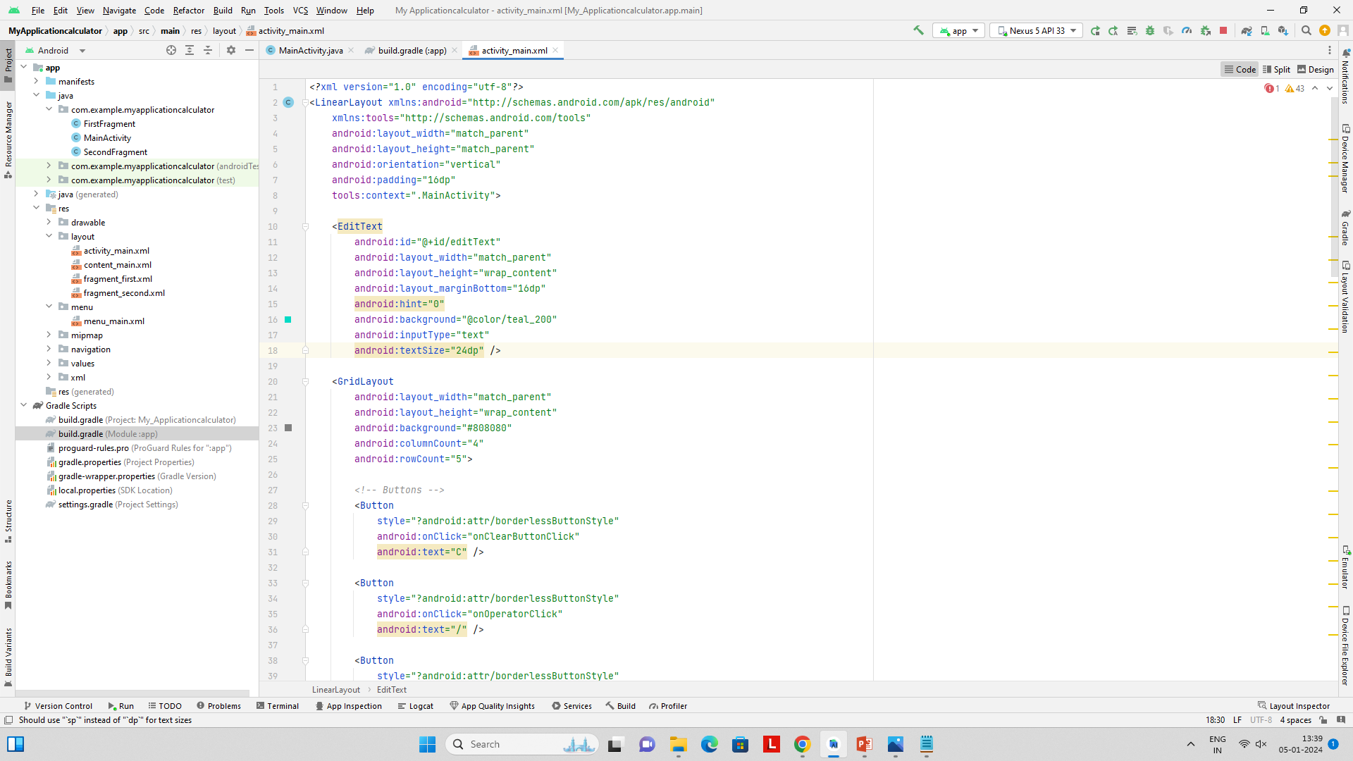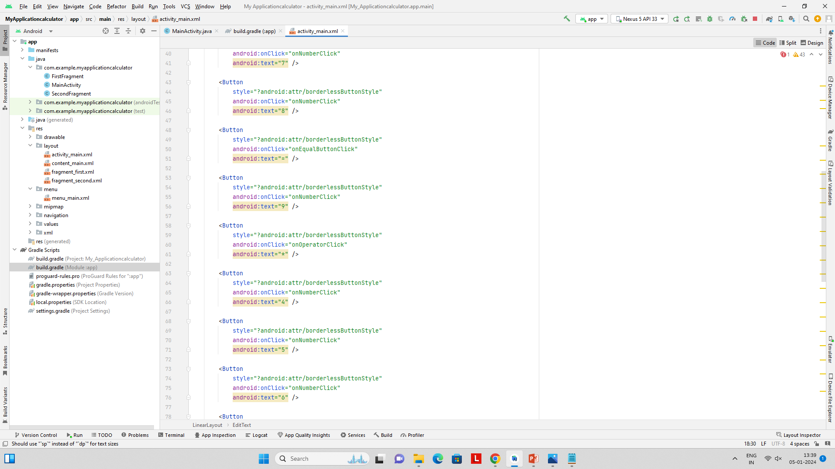

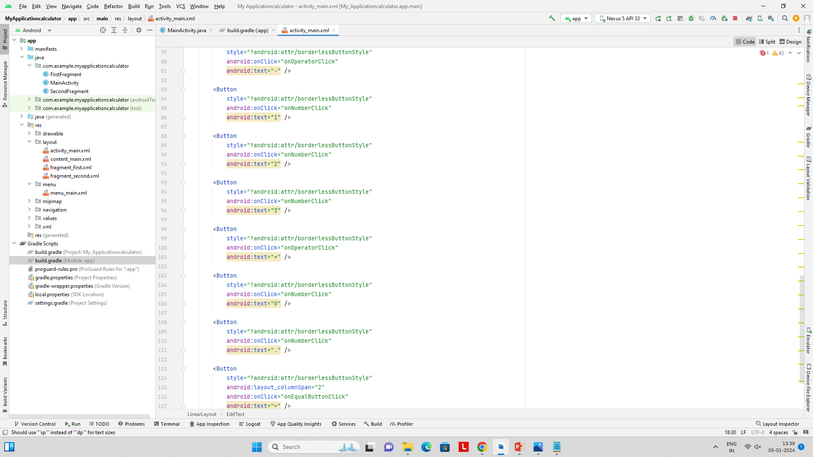

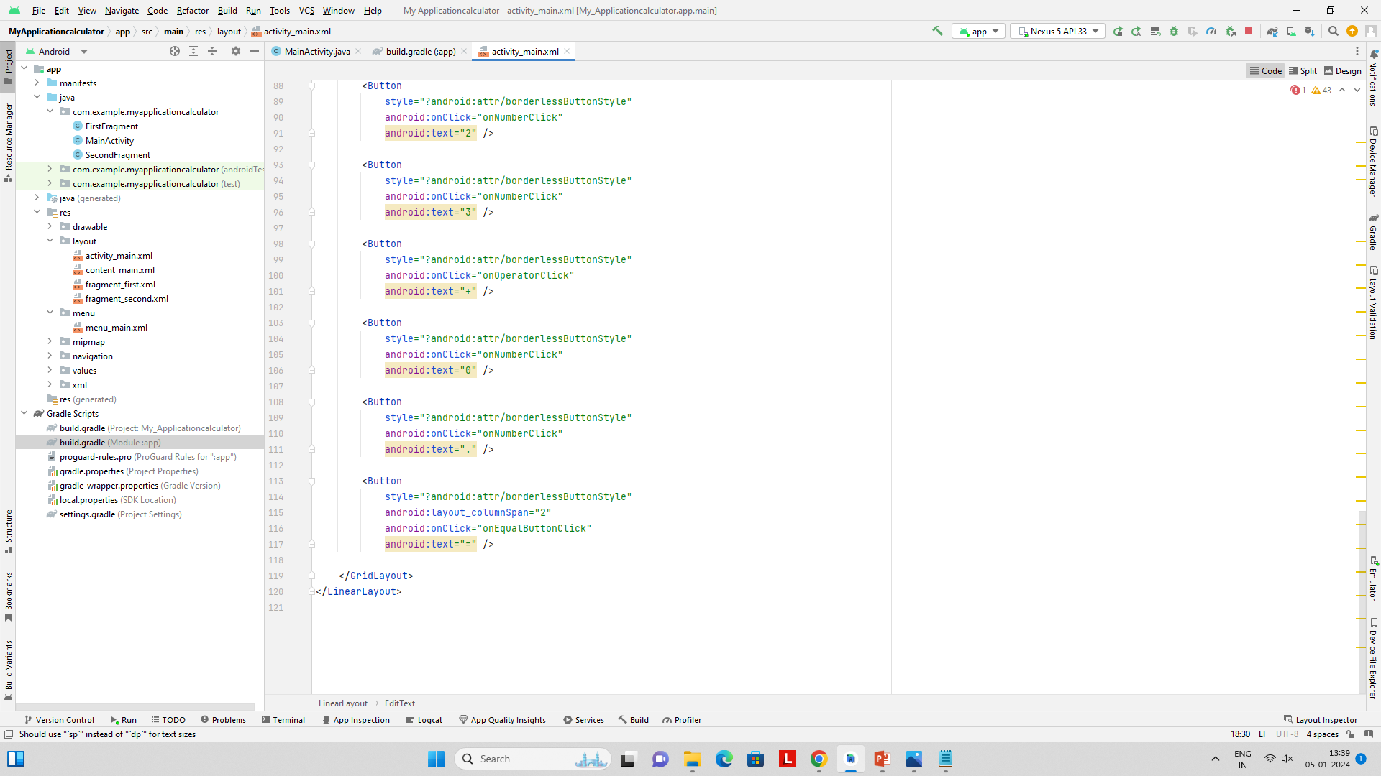

Gradle :

plugins **{**

id 'com.android.application'

**}**

android **{**

namespace 'com.example.myapplicationcalculator'

compileSdk 34

defaultConfig **{**

applicationId "com.example.myapplicationcalculator"

minSdk 27

targetSdk 34

versionCode 1

versionName "1.0"

testInstrumentationRunner "androidx.test.runner.AndroidJUnitRunner"

**}**

buildTypes **{**

release **{**

minifyEnabled false

proguardFiles getDefaultProguardFile('proguard-android-optimize.txt'), 'proguard-rules.pro'

**}**

**}**

compileOptions **{**

sourceCompatibility JavaVersion.*VERSION_1_8*

targetCompatibility JavaVersion.*VERSION_1_8*

**}**

buildFeatures **{**

viewBinding true

**}**

**}**

dependencies **{**

implementation 'androidx.appcompat:appcompat:1.6.1'

implementation 'com.google.android.material:material:1.11.0'

implementation 'androidx.constraintlayout:constraintlayout:2.1.4'

implementation 'androidx.navigation:navigation-fragment:2.7.6'

implementation 'androidx.navigation:navigation-ui:2.7.6'

testImplementation 'junit:junit:4.13.2'

androidTestImplementation 'androidx.test.ext:junit:1.1.5'

androidTestImplementation 'androidx.test.espresso:espresso-core:3.5.1'

implementation 'org.mariuszgromada.math:MathParser.org-mXparser:4.4.2'

**}**

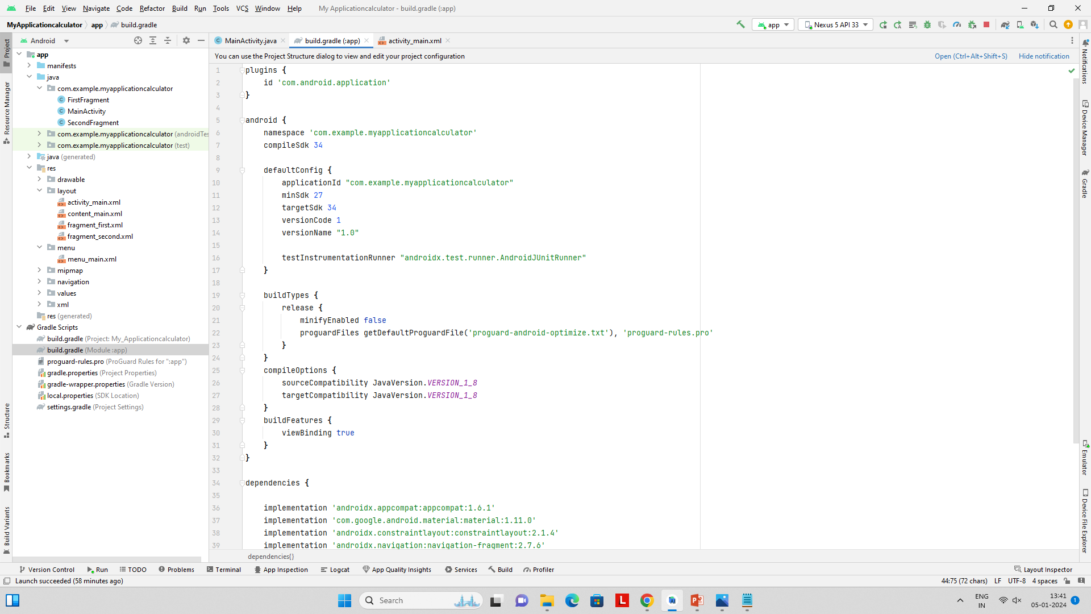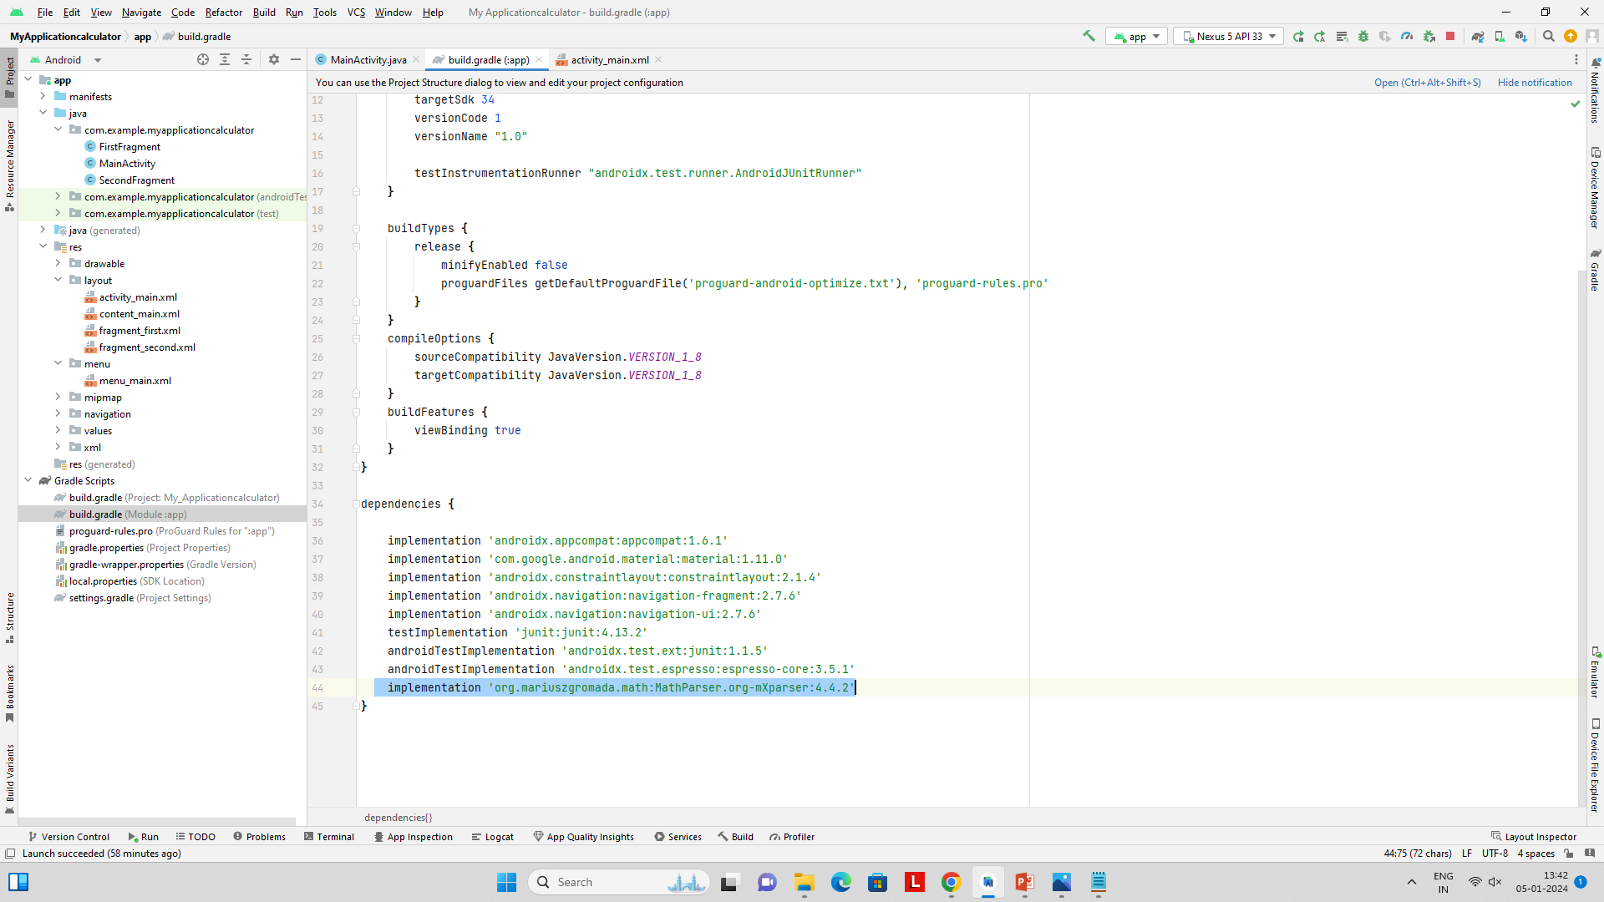

Output:

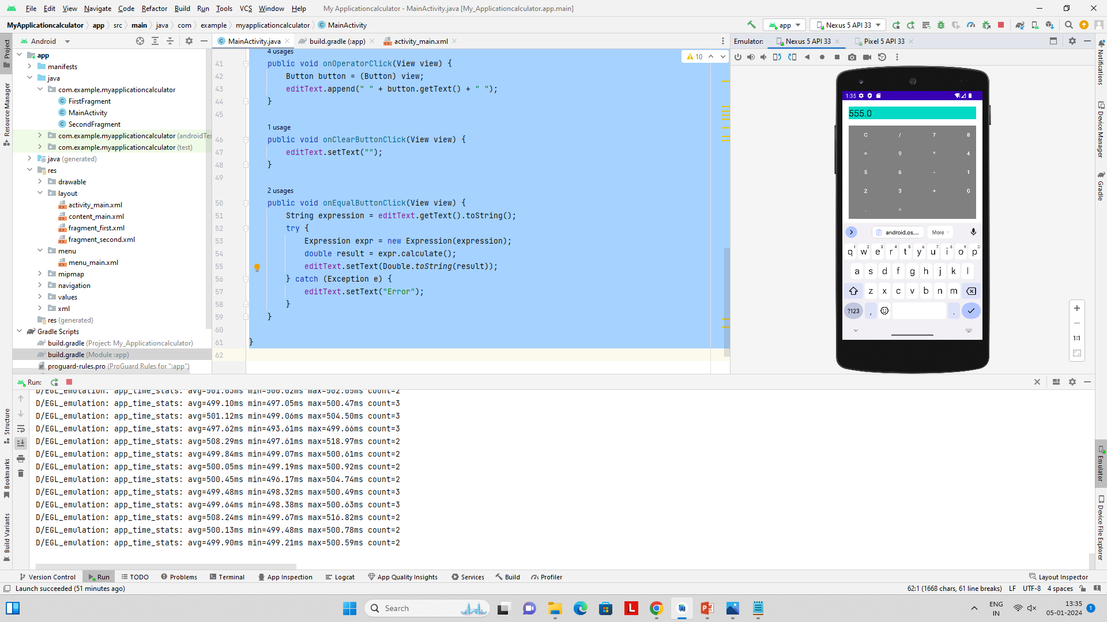

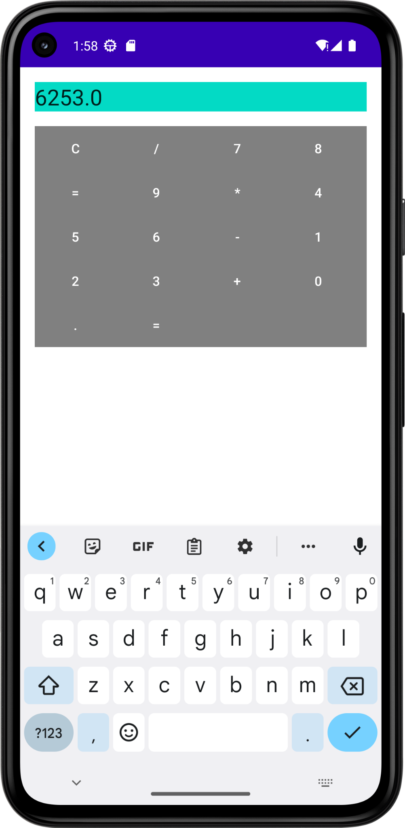

**sqlitedatabaseactivity.java**

package com.example.sqlitedatabaseactivity;

import static android.widget.Toast.*makeText*;

import android.annotation.SuppressLint;

import android.database.Cursor;

import android.os.Bundle;

import com.google.android.material.snackbar.Snackbar;

import androidx.appcompat.app.AppCompatActivity;

import android.text.Editable;

import android.view.View;

import androidx.navigation.NavController;

import androidx.navigation.Navigation;

import androidx.navigation.ui.AppBarConfiguration;

import androidx.navigation.ui.NavigationUI;

import com.example.sqlitedatabaseactivity.databinding.ActivityMainBinding;

import android.view.Menu;

import android.view.MenuItem;

import android.widget.Button;

import android.widget.EditText;

import android.widget.TextView;

import android.widget.Toast;

public class SQLiteDatabaseActivity extends AppCompatActivity {

private DbAdapter dbAdapter;

@Override

protected void onCreate(Bundle savedInstanceState) {

super.onCreate(savedInstanceState);

setContentView(R.layout.*activity_sqlite*);

dbAdapter = new DbAdapter(this);

dbAdapter.open();

EditText eTName=findViewById(R.id.*edtTextName*);

EditText eTAge=findViewById(R.id.*edtTextAge*);

Button btnInsert = findViewById(R.id.*btnInsert*);

Button btnRetrieve = findViewById(R.id.*btnRetrieve*);

Button btnUpdate = findViewById(R.id.*btnUpdate*);

Button btnDelete = findViewById(R.id.*btnDelete*);

Button btnRetrieveParticularRecord=findViewById(R.id.*btnRetrieveRecord*);

EditText eTrowId=findViewById(R.id.*edtTextRowId*);

TextView tvRecordResult=findViewById(R.id.*tvRecordResult*);

btnInsert.setOnClickListener(new View.OnClickListener() {

@Override

public void onClick(View v) {

String name=eTName.getText().toString();

String ageString=eTAge.getText().toString();

int age=Integer.*valueOf*(ageString);

*// Example: Insert a record*

long rowId = dbAdapter.insertRecord(name,age);

if (rowId != -1) {

showToast("Record inserted with ID: " + rowId);

} else {

showToast("Failed to insert record");

}

}

});

btnRetrieve.setOnClickListener(new View.OnClickListener() {

@Override

public void onClick(View v) {

*// Example: Retrieve all records*

Cursor cursor = dbAdapter.getAllRecords();

if (cursor != null && cursor.getCount() > 0) {

*// Handle retrieved records*

showToast("Number of records: " + cursor.getCount());

} else {

showToast("No records found");

}

}

});

btnUpdate.setOnClickListener(new View.OnClickListener() {

@Override

public void onClick(View v) {

Editable editTextRowId=eTrowId.getText();

String idString = editTextRowId.toString();

*// Example: Update a record*

if(!idString.isEmpty()) {

long id = Long.*parseLong*(idString);

boolean success = dbAdapter.updateRecord(id, "Updated Name", 30);

if (success) {

showToast("Record updated successfully");

} else {

showToast("Failed to update record");

}

}else {

showToast("Id is Empty");

}

}

});

btnDelete.setOnClickListener(new View.OnClickListener() {

@Override

public void onClick(View v) {

Editable editTextRowId=eTrowId.getText();

String idString = editTextRowId.toString();

*// Example: Delete a record*

if(!idString.isEmpty()) {

long id = Long.*parseLong*(idString);

boolean success = dbAdapter.deleteRecord(id);

if (success) {

showToast("Record deleted successfully");

} else {

showToast("Failed to delete record");

}

}else {

showToast("Id is Empty");

}

}

});

btnRetrieveParticularRecord.setOnClickListener(new View.OnClickListener() {

@Override

public void onClick(View v) {

Editable editTextRowId=eTrowId.getText();

String idString = editTextRowId.toString();

if (!idString.isEmpty()) {

try {

*// Parse the string to a long*

long recordId = Long.*parseLong*(idString);

*// Call getRecord to retrieve the record*

Cursor cursor = dbAdapter.getRecord(recordId);

if (cursor != null && cursor.moveToFirst()) {

*// Retrieve data from the cursor*

@SuppressLint("Range") String name = cursor.getString(cursor.getColumnIndex(DbAdapter.*KEY_NAME*));

@SuppressLint("Range") int age = cursor.getInt(cursor.getColumnIndex(DbAdapter.*KEY_AGE*));

*// Display the result in the TextView*

String resultText = "Name: " + name + ", Age: " + age;

tvRecordResult.setText(resultText);

} else {

showToast("Record not found");

}

} catch (NumberFormatException e) {

showToast("Invalid ID format");

}

} else {

showToast("Please enter a Record ID");

}

}

});

}

private void showToast(String message) {

Toast.*makeText*(this, message, Toast.*LENGTH_SHORT*).show();

}

@Override

protected void onDestroy() {

super.onDestroy();

dbAdapter.close();

}

}

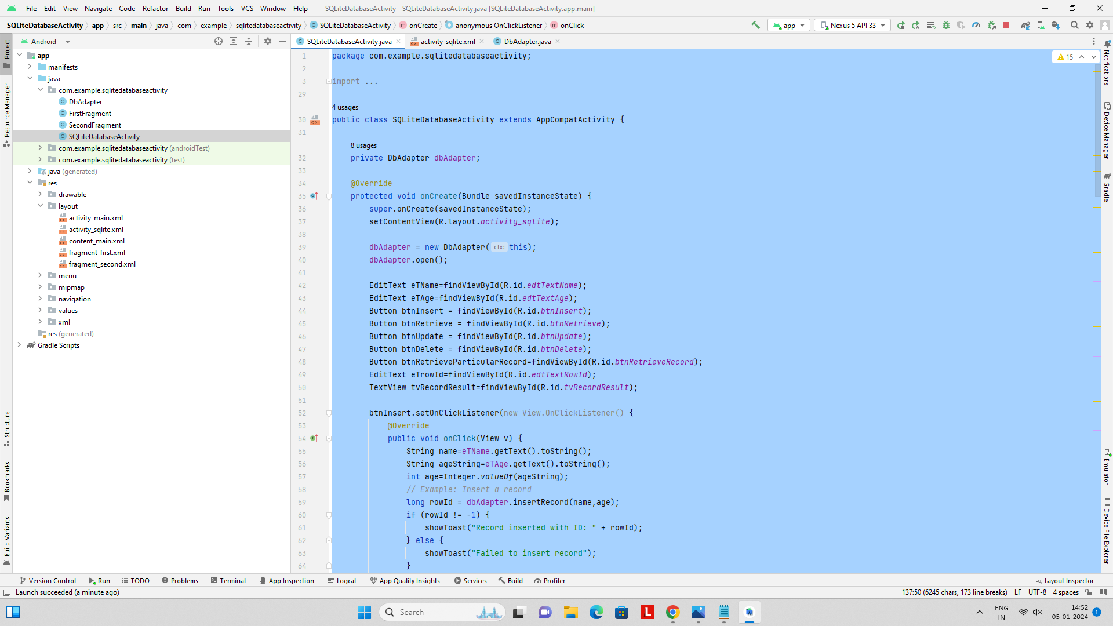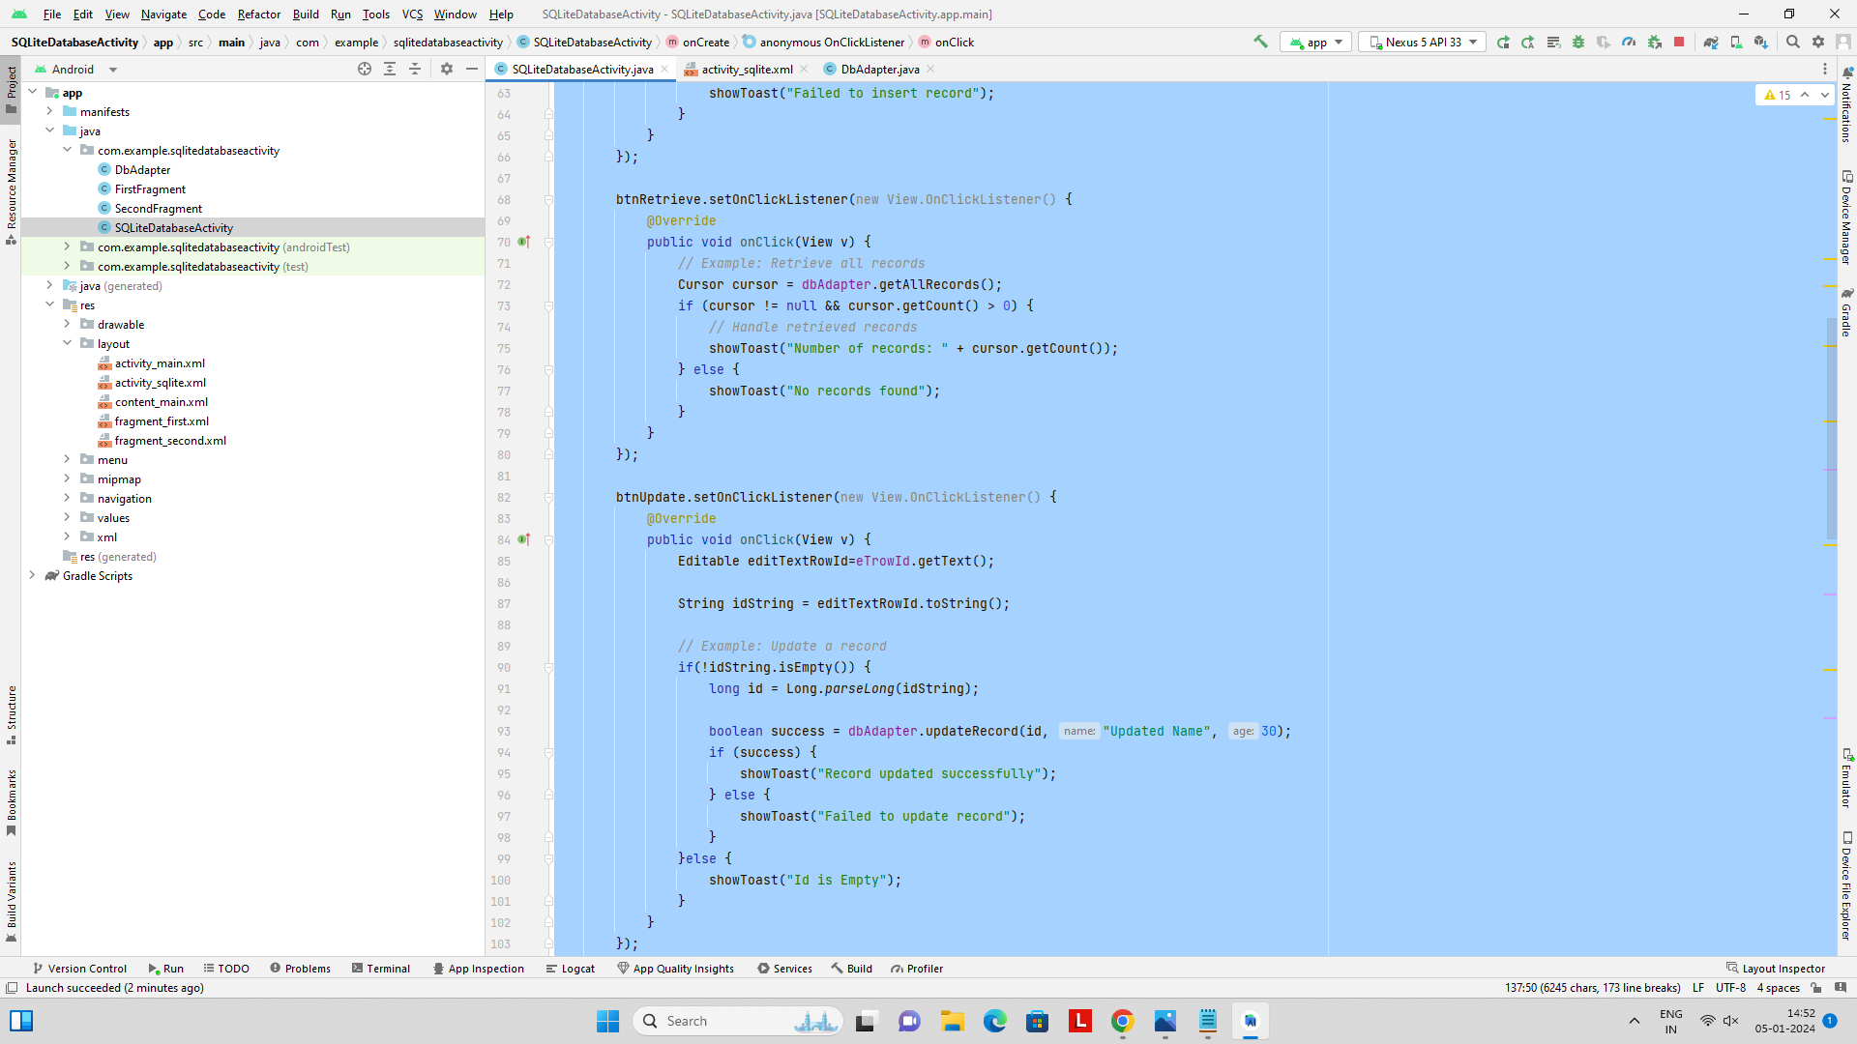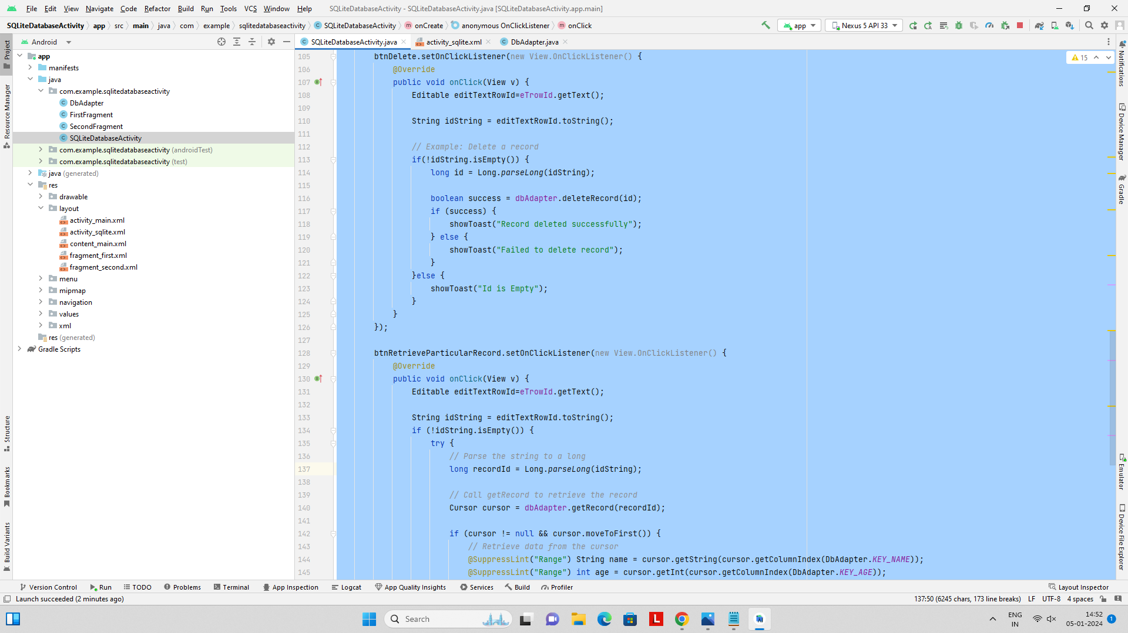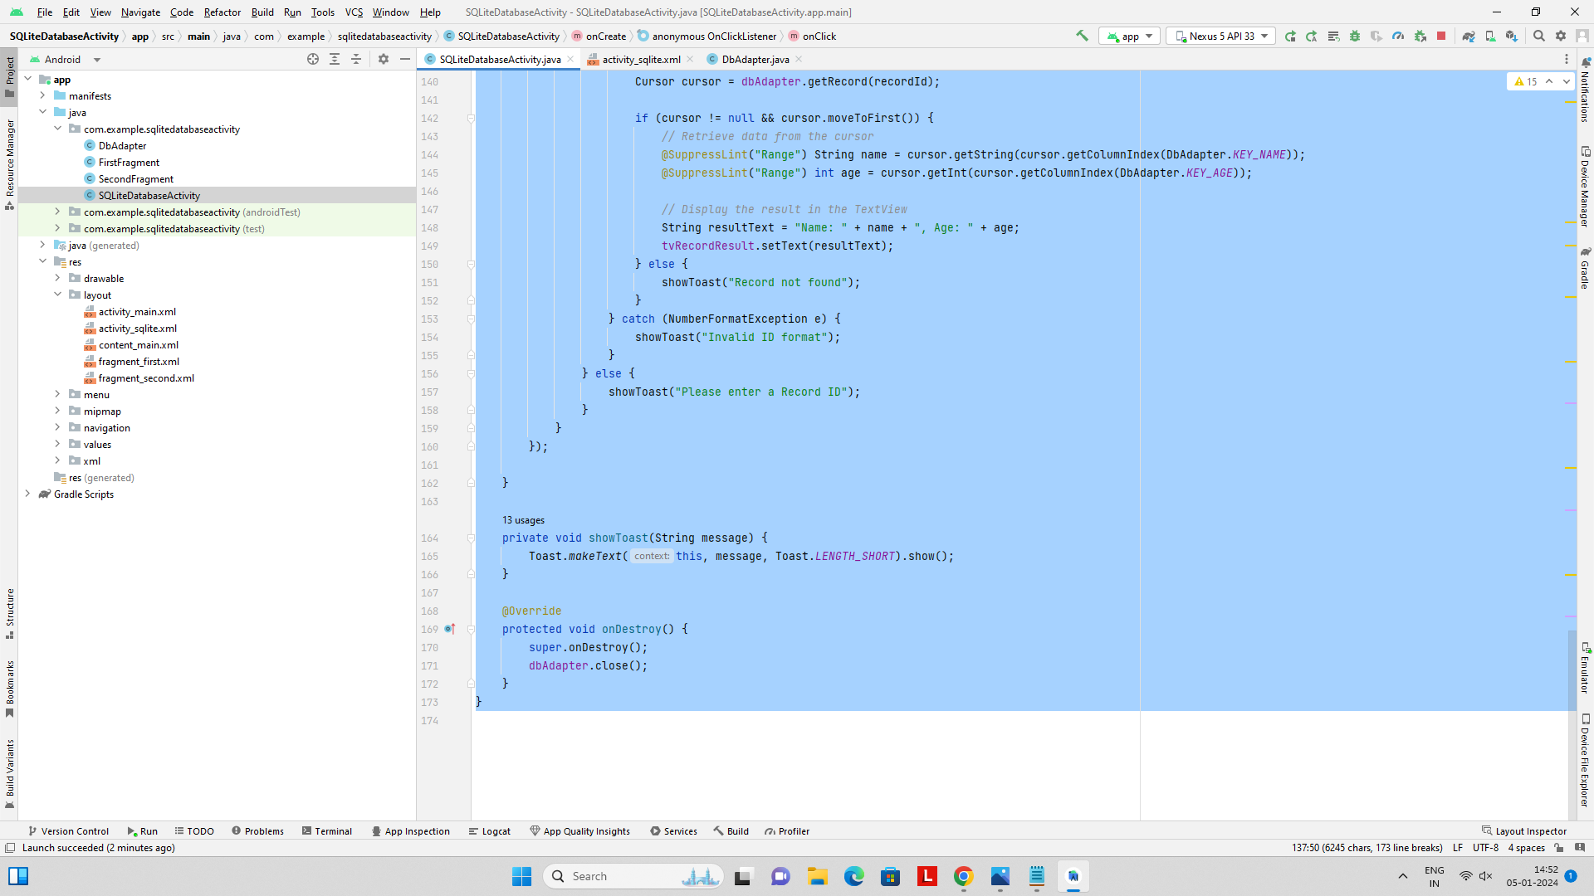

**Activity_sqlite.xml:**

*<?*xml version="1.0" encoding="utf-8"*?>*

<LinearLayout xmlns:android="http://schemas.android.com/apk/res/android"

xmlns:tools="http://schemas.android.com/tools"

android:layout_width="match_parent"

android:layout_height="match_parent"

android:orientation="vertical"

android:padding="16dp"

android:gravity="center"

tools:context=".SQLiteDatabaseActivity">

<TextView

android:layout_width="match_parent"

android:layout_height="wrap_content"

android:text="Enter Name:"

android:textSize="20dp"/>

<EditText

android:id="@+id/edtTextName"

android:layout_width="match_parent"

android:textSize="20dp"

android:layout_height="wrap_content"/>

<TextView

android:layout_width="match_parent"

android:layout_height="wrap_content"

android:text="Enter Age:"

android:textSize="20dp"/>

<EditText

android:id="@+id/edtTextAge"

android:layout_width="match_parent"

android:textSize="20dp"

android:layout_height="wrap_content"/>

<Button

android:id="@+id/btnInsert"

android:layout_width="match_parent"

android:layout_height="wrap_content"

android:text="Insert Record" />

<Button

android:id="@+id/btnRetrieve"

android:layout_width="match_parent"

android:layout_height="wrap_content"

android:text="Total Records Count" />

<TextView

android:layout_width="match_parent"

android:layout_height="wrap_content"

android:text="Enter rowId:"

android:textSize="20dp"/>

<EditText

android:id="@+id/edtTextRowId"

android:layout_width="match_parent"

android:textSize="20dp"

android:layout_height="wrap_content"/>

<Button

android:id="@+id/btnUpdate"

android:layout_width="match_parent"

android:layout_height="wrap_content"

android:text="Update Record" />

<Button

android:id="@+id/btnDelete"

android:layout_width="match_parent"

android:layout_height="wrap_content"

android:text="Delete Record" />

<Button

android:id="@+id/btnRetrieveRecord"

android:layout_width="match_parent"

android:layout_height="wrap_content"

android:text="Retrieve Particular Record" />

<TextView

android:id="@+id/tvRecordResult"

android:layout_width="match_parent"

android:layout_height="wrap_content"

android:text="" />

</LinearLayout>

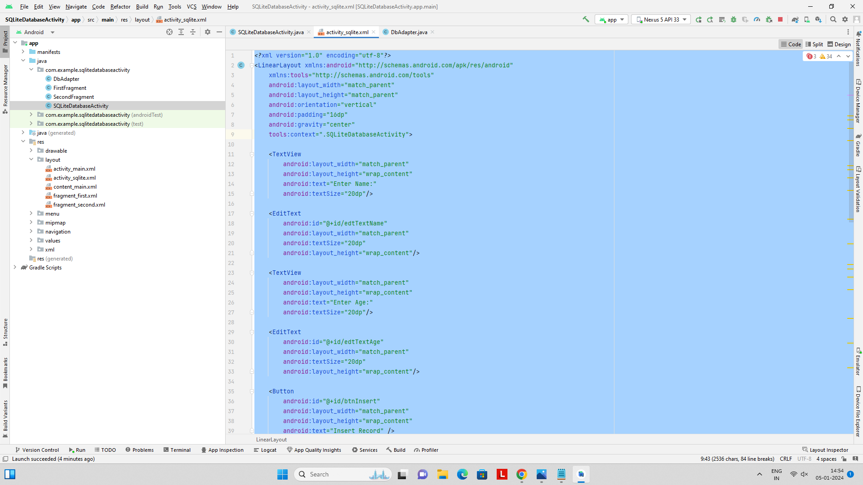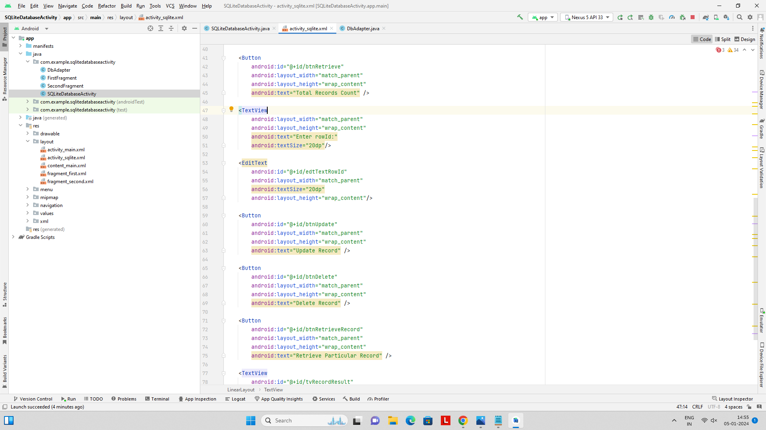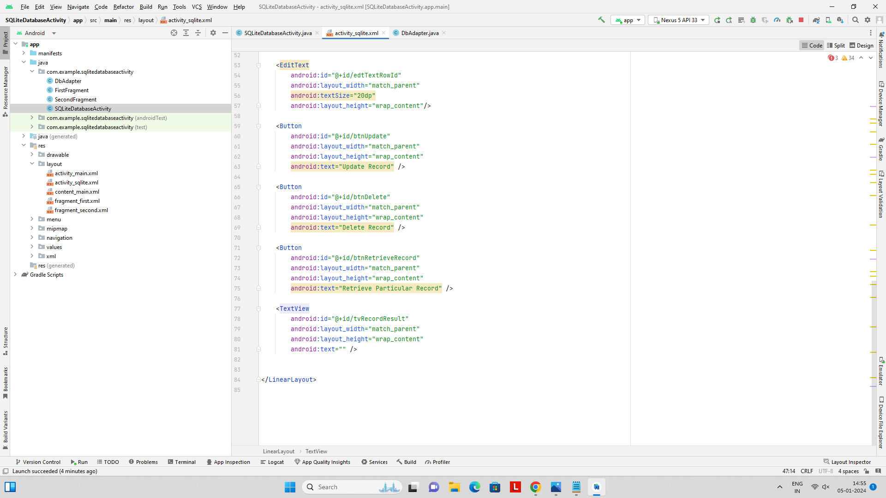

**DbAdapter:**

**package com.example.sqlitedatabaseactivity;**

**import android.content.ContentValues;**

**import android.content.Context;**

**import android.database.Cursor;**

**import android.database.SQLException;**

**import android.database.sqlite.SQLiteDatabase;**

**import android.database.sqlite.SQLiteOpenHelper;**

**public class DbAdapter {**

***// Database constants***

**private static final String *DATABASE_NAME* = "your_database";**

**private static final int *DATABASE_VERSION* = 1;**

***// Table constants***

**private static final String *TABLE_NAME* = "your_table";**

**public static final String *KEY_ID* = "_id";**

**public static final String *KEY_NAME* = "name";**

**public static final String *KEY_AGE* = "age";**

***// Database creation SQL statement***

**private static final String *DATABASE_CREATE* =**

**"create table " + *TABLE_NAME* + " ("**

**+ *KEY_ID* + " integer primary key autoincrement, "**

**+ *KEY_NAME* + " text not null, "**

**+ *KEY_AGE* + " integer not null);";**

**private final Context context;**

**private DatabaseHelper DBHelper;**

**private SQLiteDatabase db;**

**public DbAdapter(Context ctx) {**

**this.context = ctx;**

**DBHelper = new DatabaseHelper(context);**

**}**

***// Helper class to manage database creation and version management.***

**private static class DatabaseHelper extends SQLiteOpenHelper {**

**DatabaseHelper(Context context) {**

**super(context, *DATABASE_NAME*, null, *DATABASE_VERSION*);**

**}**

**@Override**

**public void onCreate(SQLiteDatabase db) {**

**try {**

**db.execSQL(*DATABASE_CREATE*);**

**} catch (SQLException e) {**

**e.printStackTrace();**

**}**

**}**

**@Override**

**public void onUpgrade(SQLiteDatabase db, int oldVersion, int newVersion) {**

***// Implement if you need to handle database upgrades***

**}**

**}**

***// Open the database***

**public DbAdapter open() throws SQLException {**

**db = DBHelper.getWritableDatabase();**

**return this;**

**}**

***// Close the database***

**public void close() {**

**DBHelper.close();**

**}**

***// Insert a record into the database***

**public long insertRecord(String name, int age) {**

**ContentValues initialValues = new ContentValues();**

**initialValues.put(*KEY_NAME*, name);**

**initialValues.put(*KEY_AGE*, age);**

**return db.insert(*TABLE_NAME*, null, initialValues);**

**}**

***// Retrieve all records from the database***

**public Cursor getAllRecords() {**

**return db.query(*TABLE_NAME*, new String[]{*KEY_ID*, *KEY_NAME*, *KEY_AGE*},**

**null, null, null, null, null);**

**}**

***// Retrieve a specific record based on ID***

**public Cursor getRecord(long rowId) throws SQLException {**

**Cursor cursor = db.query(true, *TABLE_NAME*,**

**new String[]{*KEY_ID*, *KEY_NAME*, *KEY_AGE*},**

***KEY_ID* + "=" + rowId,**

**null, null, null, null, null);**

**if (cursor != null) {**

**cursor.moveToFirst();**

**}**

**return cursor;**

**}**

***// Update a record in the database***

**public boolean updateRecord(long rowId, String name, int age) {**

**ContentValues args = new ContentValues();**

**args.put(*KEY_NAME*, name);**

**args.put(*KEY_AGE*, age);**

**return db.update(*TABLE_NAME*, args, *KEY_ID* + "=" + rowId, null) > 0;**

**}**

***// Delete a record from the database***

**public boolean deleteRecord(long rowId) {**

**return db.delete(*TABLE_NAME*, *KEY_ID* + "=" + rowId, null) > 0;**

**}**

**}**

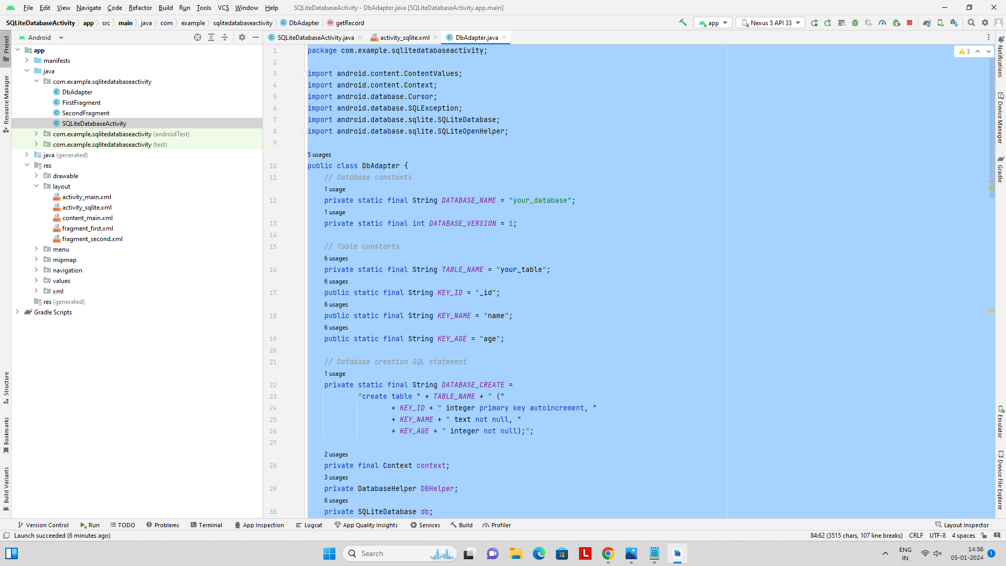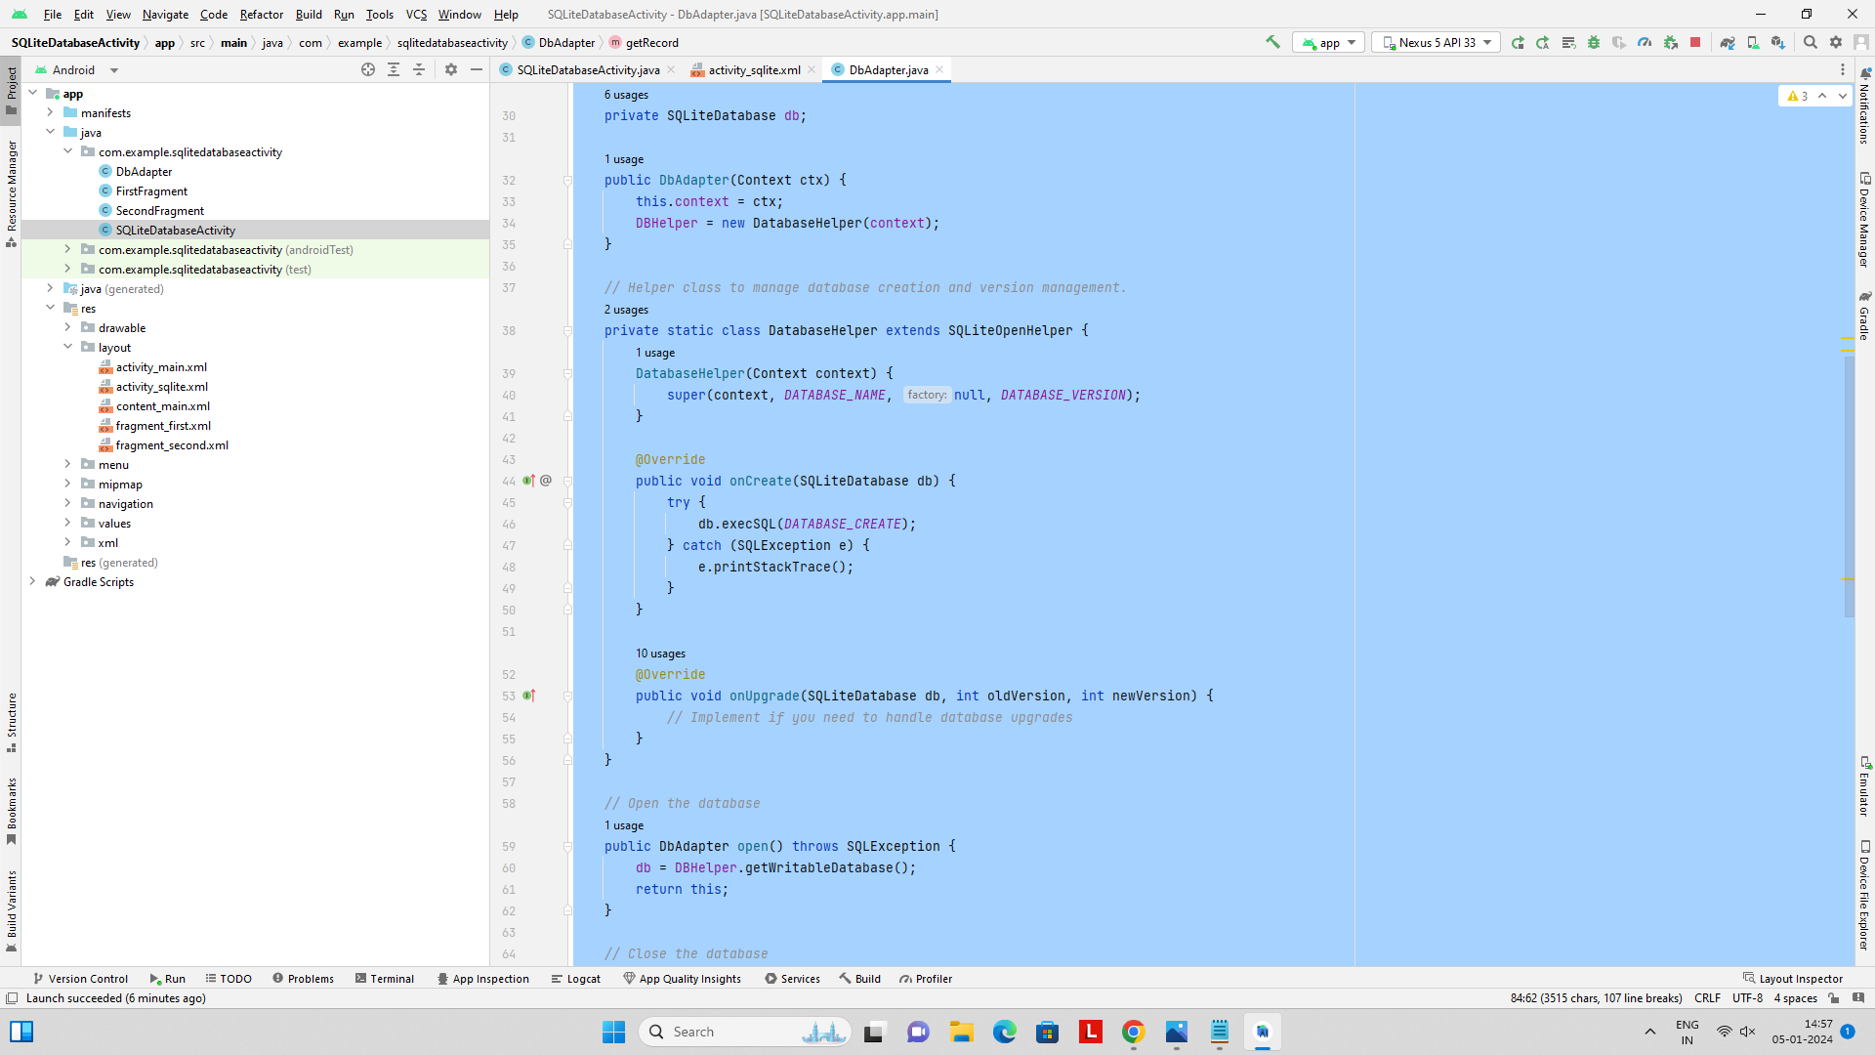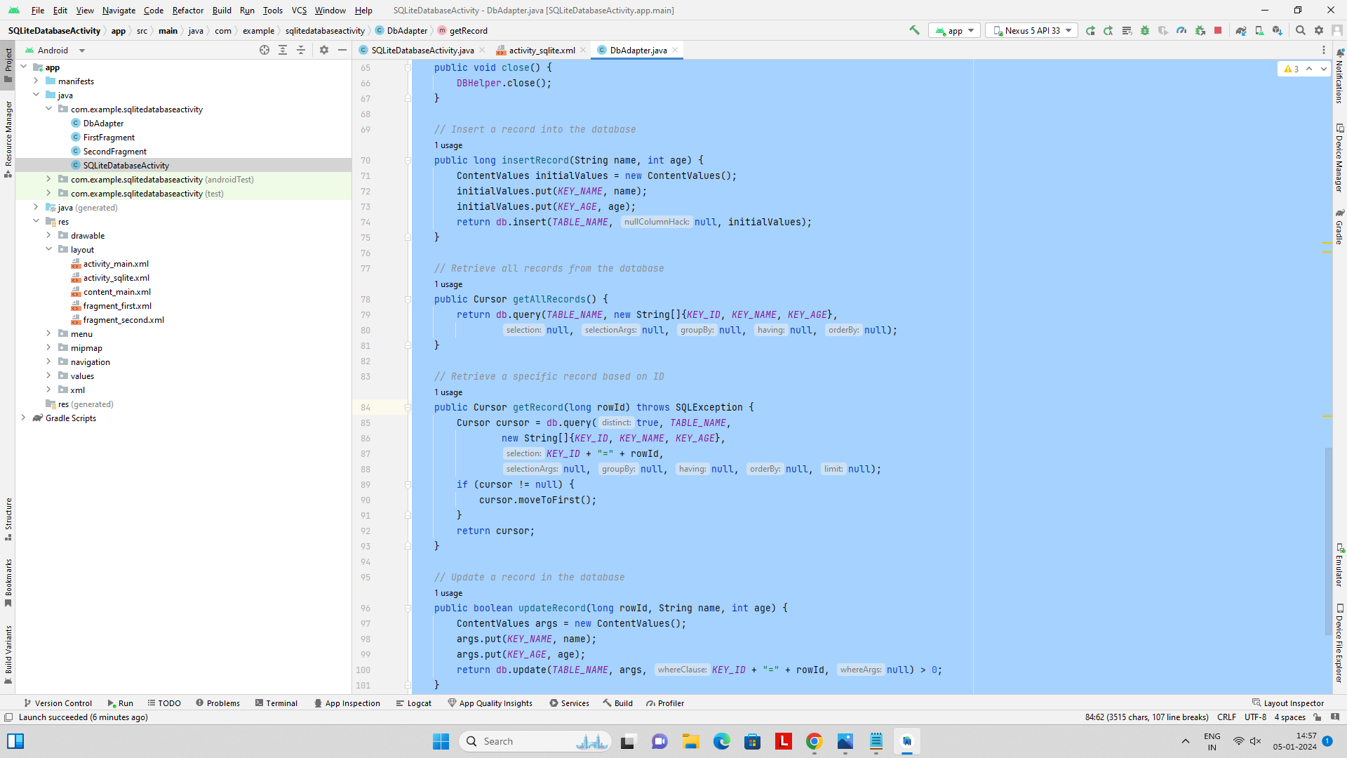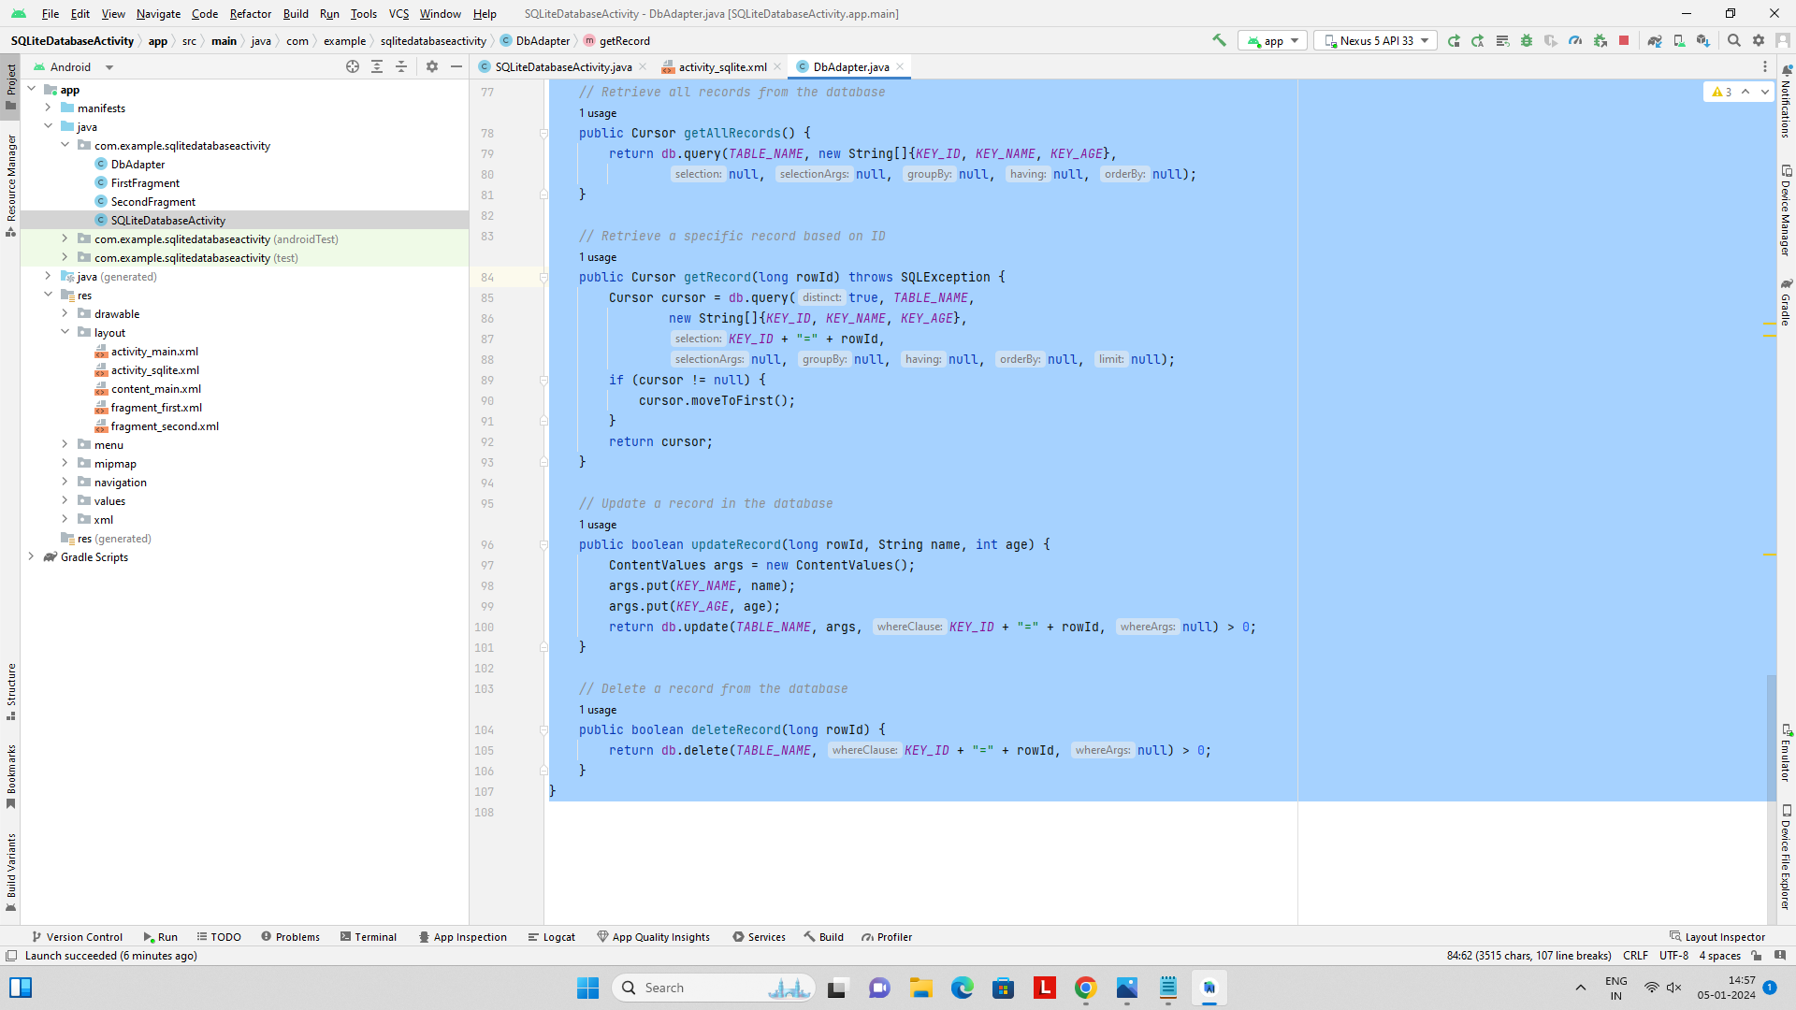

**OUTPUT:**

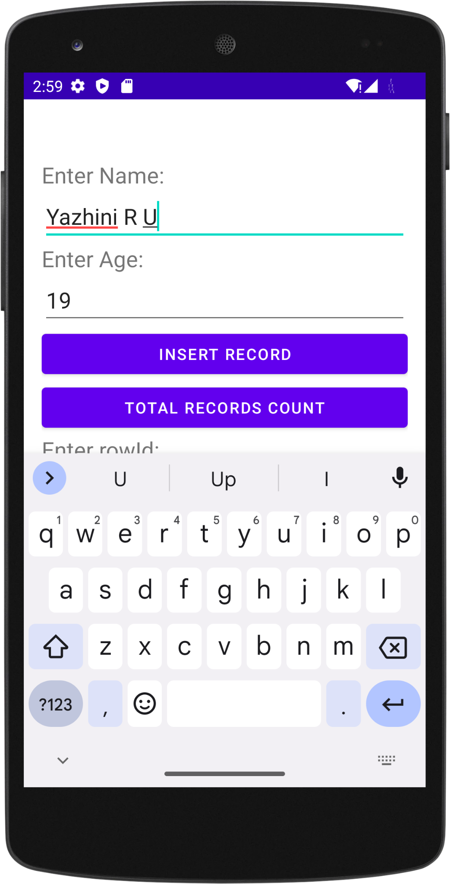

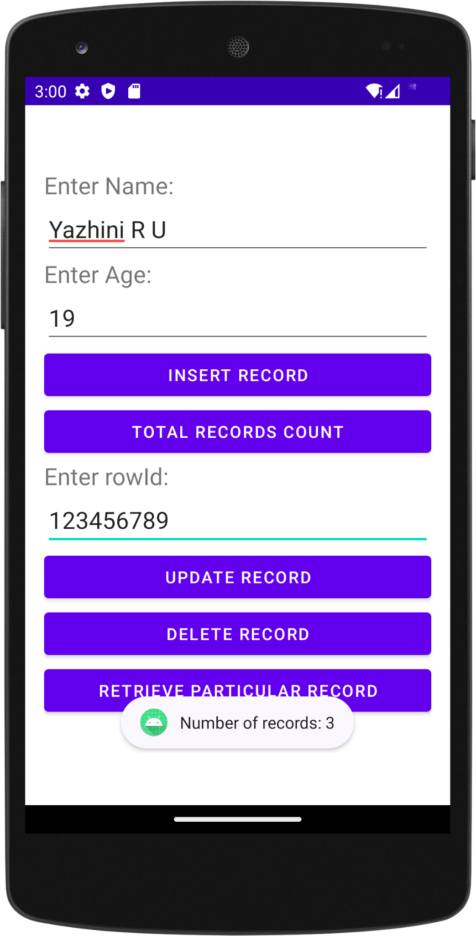

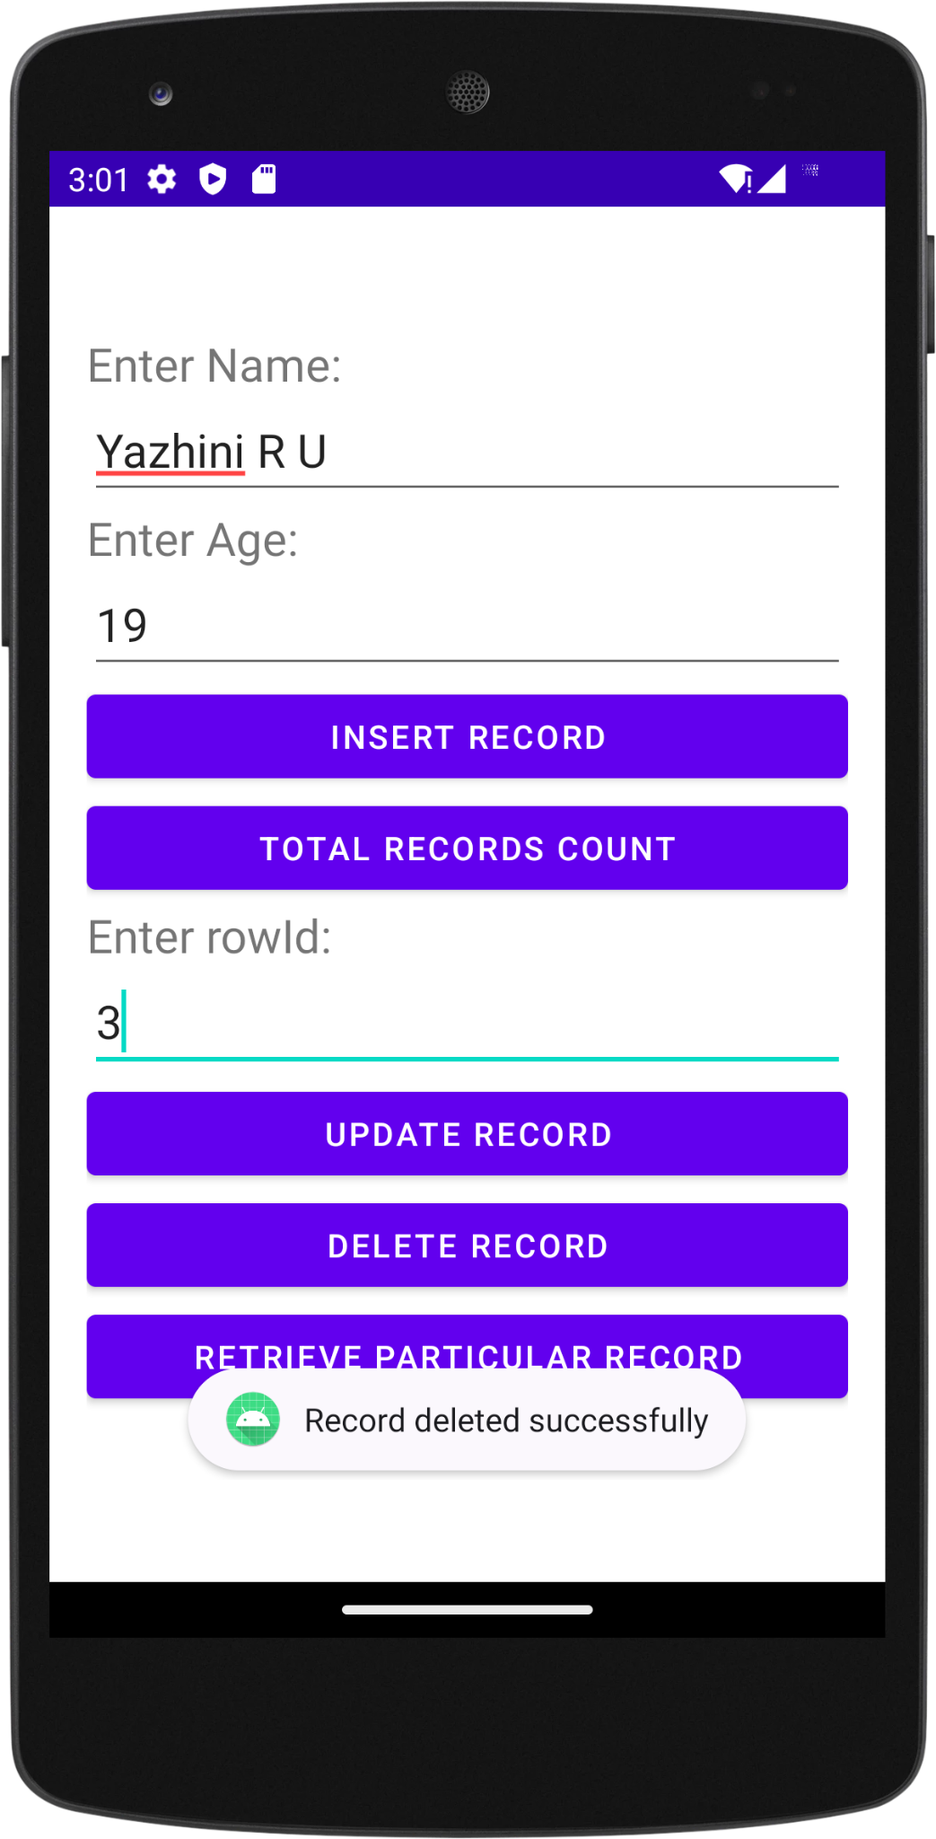

**STOPWATCH:**

**StopwatchActivity.java**

**package com.example.stopwatch;**

**import android.os.Bundle;**

**import android.os.Handler;**

**import android.view.View;**

**import android.widget.TextView;**

**import androidx.appcompat.app.AppCompatActivity;**

**import org.jetbrains.annotations.Nullable;**

**import java.util.Locale;**

**public class StopwatchActivity extends AppCompatActivity {**

**private int seconds = 0;**

***// Is the stopwatch running?***

**private boolean running;**

**private boolean wasRunning;**

**@Override**

**protected void onCreate(@Nullable Bundle savedInstanceState) {**

**super.onCreate(savedInstanceState);**

**setContentView(R.layout.*activity_stopwatch*);**

**if (savedInstanceState != null) {**

***// Get the previous state of the stopwatch***

***// if the activity has been***

***// destroyed and recreated.***

**seconds = savedInstanceState.getInt("seconds");**

**running = savedInstanceState.getBoolean("running");**

**wasRunning = savedInstanceState.getBoolean("wasRunning");**

**}**

**runTimer();**

**}**

**private void runTimer() {**

**final TextView timeView = (TextView) findViewById(R.id.*time_view*);**

**Handler handler = new Handler();**

**handler.post(new Runnable() {**

**@Override**

**public void run() {**

**int hours = seconds / 3600; *//3600=1 hr***

**int minutes = (seconds % 3600) / 60;**

**int secs = seconds % 60;**

**String time = String.*format*(Locale.*getDefault*(), "%d:%02d:%02d", hours,**

**minutes, secs);**

**timeView.setText(time);**

**if (running) {**

**seconds++;**

**}**

***// Post the code again***

***// with a delay of 1 second.***

**handler.postDelayed(this, 1000);**

**}**

**});**

**}**

**@Override**

**public void onSaveInstanceState(Bundle savedInstanceState) {**

**super.onSaveInstanceState(savedInstanceState);**

**savedInstanceState.putInt("seconds", seconds);**

**savedInstanceState.putBoolean("running", running);**

**savedInstanceState.putBoolean("wasRunning", wasRunning);**

**}**

**@Override**

**protected void onPause() {**

**super.onPause();**

**wasRunning = running;**

**running = false;**

**}**

***// If the activity is resumed,***

***// start the stopwatch***

***// again if it was running previously.***

**@Override**

**protected void onResume() {**

**super.onResume();**

**if (wasRunning) {**

**running = true;**

**}**

**}**

***// Start the stopwatch running***

***// when the Start button is clicked.***

***// Below method gets called***

***// when the Start button is clicked.***

**public void onClickStart(View view) {**

**running = true;**

**}**

***// Stop the stopwatch running***

***// when the Stop button is clicked.***

***// Below method gets called***

***// when the Stop button is clicked.***

**public void onClickStop(View view) {**

**running = false;**

**}**

***// Reset the stopwatch when***

***// the Reset button is clicked.***

***// Below method gets called***

***// when the Reset button is clicked.***

**public void onClickReset(View view) {**

**running = false;**

**seconds = 0;**

**}**

**}**

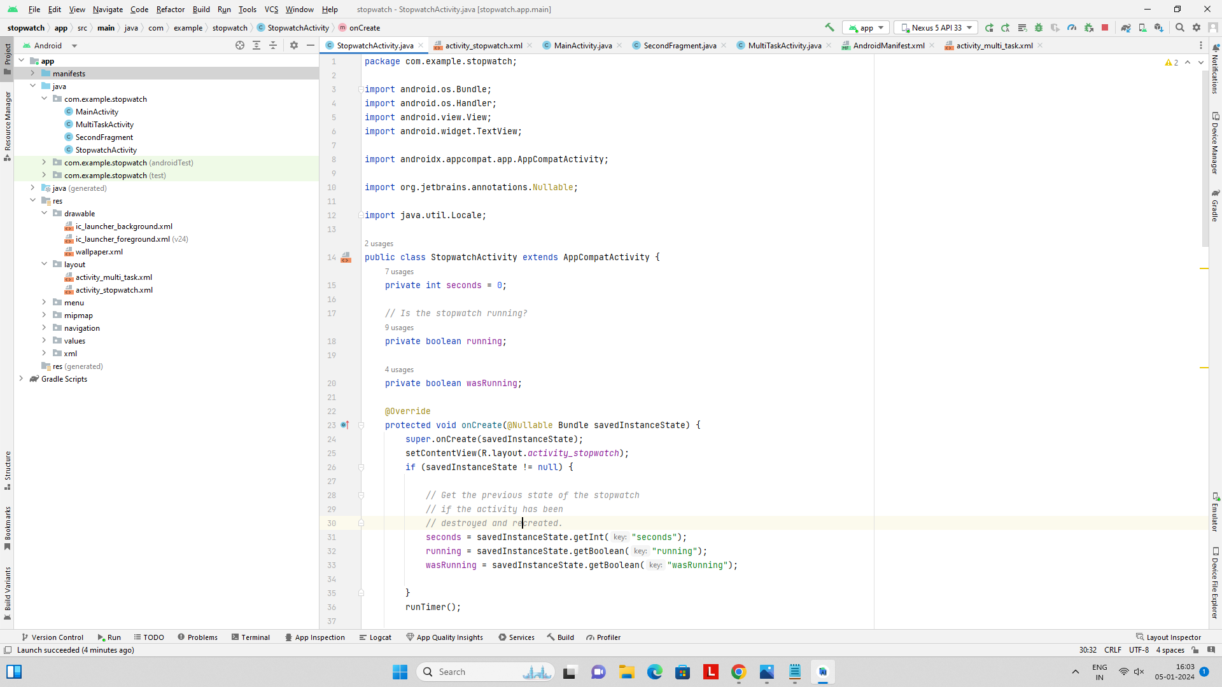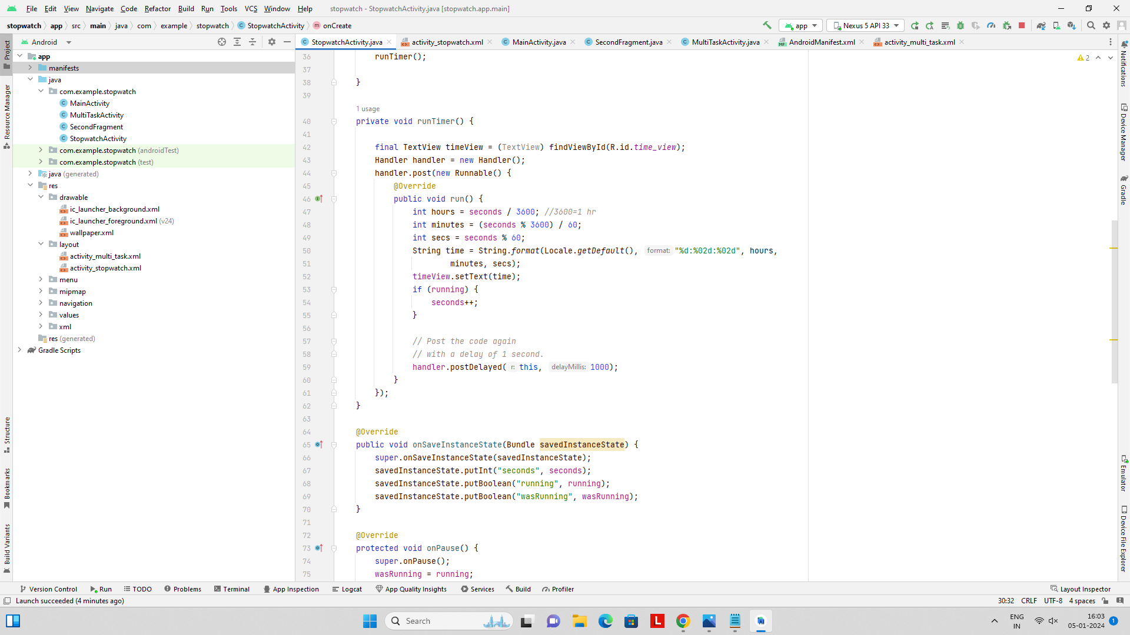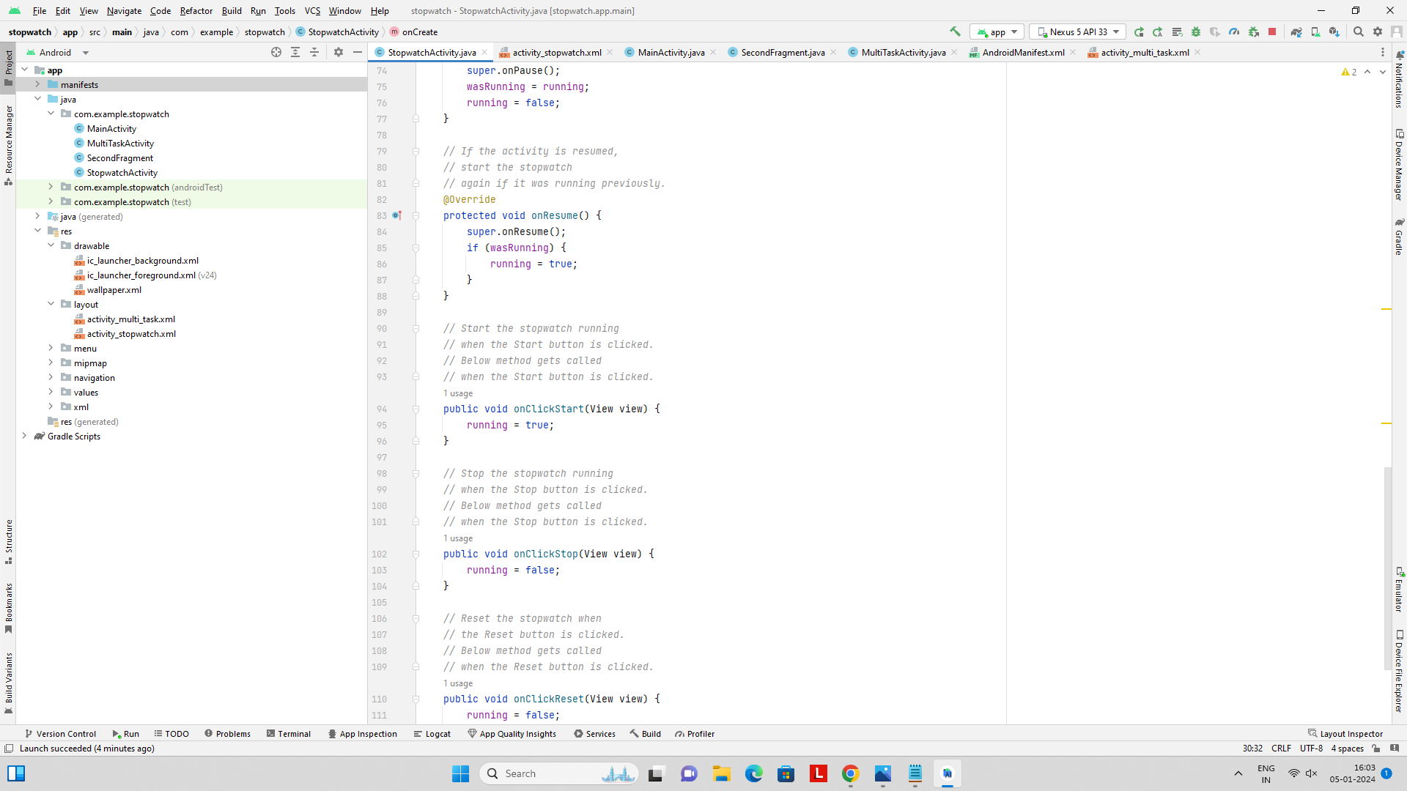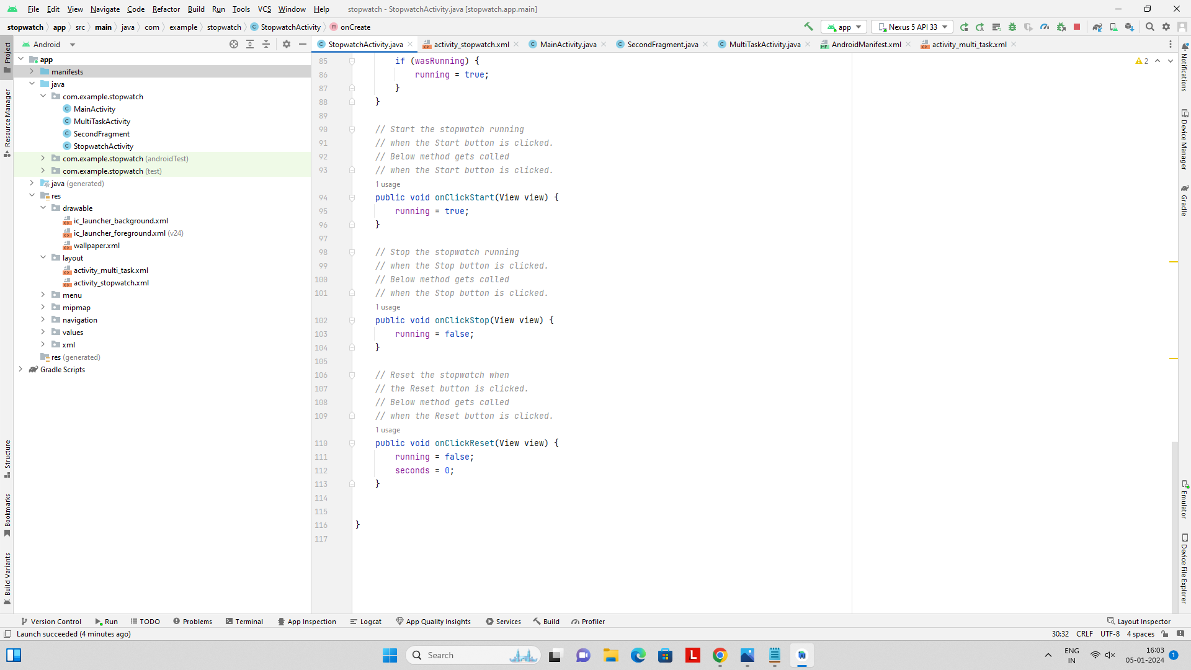

**Activity_stopwatch.xml:**

***<?*xml version="1.0" encoding="utf-8"*?>***

**<LinearLayout xmlns:android="http://schemas.android.com/apk/res/android"**

**android:layout_width="match_parent"**

**android:layout_height="match_parent"**

**android:background="#0F9D58"**

**android:layout_gravity="center"**

**android:gravity="center"**

**android:orientation="vertical"**

**android:padding="16dp">**

**<TextView**

**android:id="@+id/time_view"**

**android:layout_width="wrap_content"**

**android:layout_height="wrap_content"**

**android:layout_gravity="center_horizontal"**

**android:textAppearance="@android:style/TextAppearance.Large"**

**android:textSize="56sp" />**

**<Button**

**android:id="@+id/start_button"**

**android:layout_width="wrap_content"**

**android:layout_height="wrap_content"**

**android:layout_gravity="center_horizontal"**

**android:layout_marginTop="20dp"**

**android:onClick="onClickStart"**

**android:text="Start" />**

**<Button**

**android:id="@+id/stop_button"**

**android:layout_width="wrap_content"**

**android:layout_height="wrap_content"**

**android:layout_gravity="center_horizontal"**

**android:layout_marginTop="8dp"**

**android:onClick="onClickStop"**

**android:text="Stop" />**

**<Button**

**android:id="@+id/reset_button"**

**android:layout_width="wrap_content"**

**android:layout_height="wrap_content"**

**android:layout_gravity="center_horizontal"**

**android:layout_marginTop="8dp"**

**android:onClick="onClickReset"**

**android:text="Reset" />**

**</LinearLayout>**

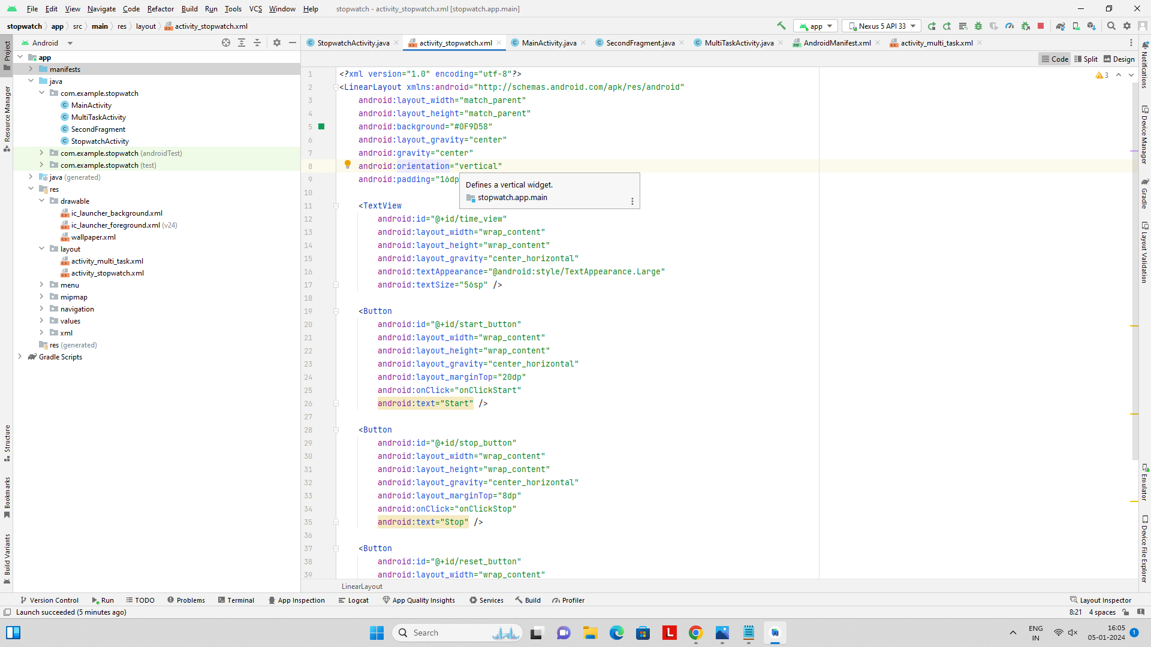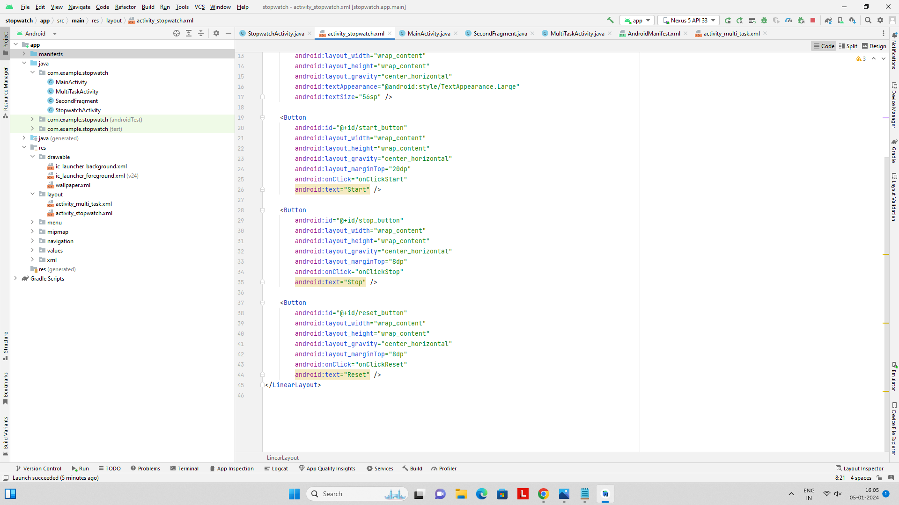

**MultiTaskActivity.java:**

**package com.example.stopwatch;**

**import android.app.WallpaperManager;**

**import android.content.Intent;**

**import android.graphics.Bitmap;**

**import android.graphics.BitmapFactory;**

**import android.os.Bundle;**

**import android.telephony.SmsManager;**

**import android.view.View;**

**import android.widget.ImageView;**

**import android.widget.Toast;**

**import androidx.appcompat.app.AppCompatActivity;**

**import java.io.IOException;public class MultiTaskActivity extends AppCompatActivity {**

***//bptnjgyjzc***

**@Override**

**protected void onCreate(Bundle savedInstanceState) {**

**super.onCreate(savedInstanceState);**

**setContentView(R.layout.*activity_multi_task*);**

**ImageView imagePreview = findViewById(R.id.*imagePreview*);**

**imagePreview.setImageResource(R.drawable.*wallpaper*);**

**findViewById(R.id.*apiCall*).setOnClickListener(new View.OnClickListener() {**

**@Override**

**public void onClick(View view) {**

***// startActivity(new Intent(getApplicationContext(), APICall.class));***

**}**

**});**

**findViewById(R.id.*txtStopWatch*).setOnClickListener(new View.OnClickListener() {**

**@Override**

**public void onClick(View view) {**

**startActivity(new Intent(getApplicationContext(), StopwatchActivity.class));**

**}**

**});**

**findViewById(R.id.*txtSetWallpaper*).setOnClickListener(new View.OnClickListener() {**

**@Override**

**public void onClick(View view) {**

**WallpaperManager myWallpaperManager = WallpaperManager.*getInstance*(getApplicationContext());**

**Bitmap bitmap = BitmapFactory.*decodeResource*(getResources(), R.drawable.*wallpaper*);**

**try {**

***//myWallpaperManager.setResource(R.drawable.motorcycle);***

**myWallpaperManager.setBitmap(bitmap);**

**Toast.*makeText*(MultiTaskActivity.this, "Wallet set success", Toast.*LENGTH_SHORT*).show();**

**} catch (IOException e) {**

**e.printStackTrace();**

**}**

**}**

**});**

**findViewById(R.id.*txtSMSSend*).setOnClickListener(new View.OnClickListener() {**

**@Override**

**public void onClick(View view) {**

**String mobile = "9788686374";**

**sendSMS(mobile, "Testing Message");**

**}**

**});**

**findViewById(R.id.*txtEmail*).setOnClickListener(new View.OnClickListener() {**

**@Override**

**public void onClick(View view) {**

**Intent email = new Intent(Intent.*ACTION_SEND*);**

**email.putExtra(Intent.*EXTRA_EMAIL*, new String[]{"nsubbu9788@gmail.com"});**

**email.putExtra(Intent.*EXTRA_SUBJECT*, "Subject");**

**email.putExtra(Intent.*EXTRA_TEXT*, "message to send email");**

***//need this to prompts email client only***

**email.setType("message/rfc822");**

**startActivity(Intent.*createChooser*(email, "Choose an Email client :"));**

**}**

**});**

**}**

**public void sendSMS(String phoneNo, String msg) {**

**try {**

**SmsManager smsManager = SmsManager.*getDefault*();**

**smsManager.sendTextMessage(phoneNo, null, msg, null, null);**

**Toast.*makeText*(getApplicationContext(), "Message Sent ", Toast.*LENGTH_LONG*).show();**

**} catch (Exception ex) {**

**Toast.*makeText*(getApplicationContext(), ex.getMessage().toString(),**

**Toast.*LENGTH_LONG*).show();**

**ex.printStackTrace();**

**}**

**}**

**}**

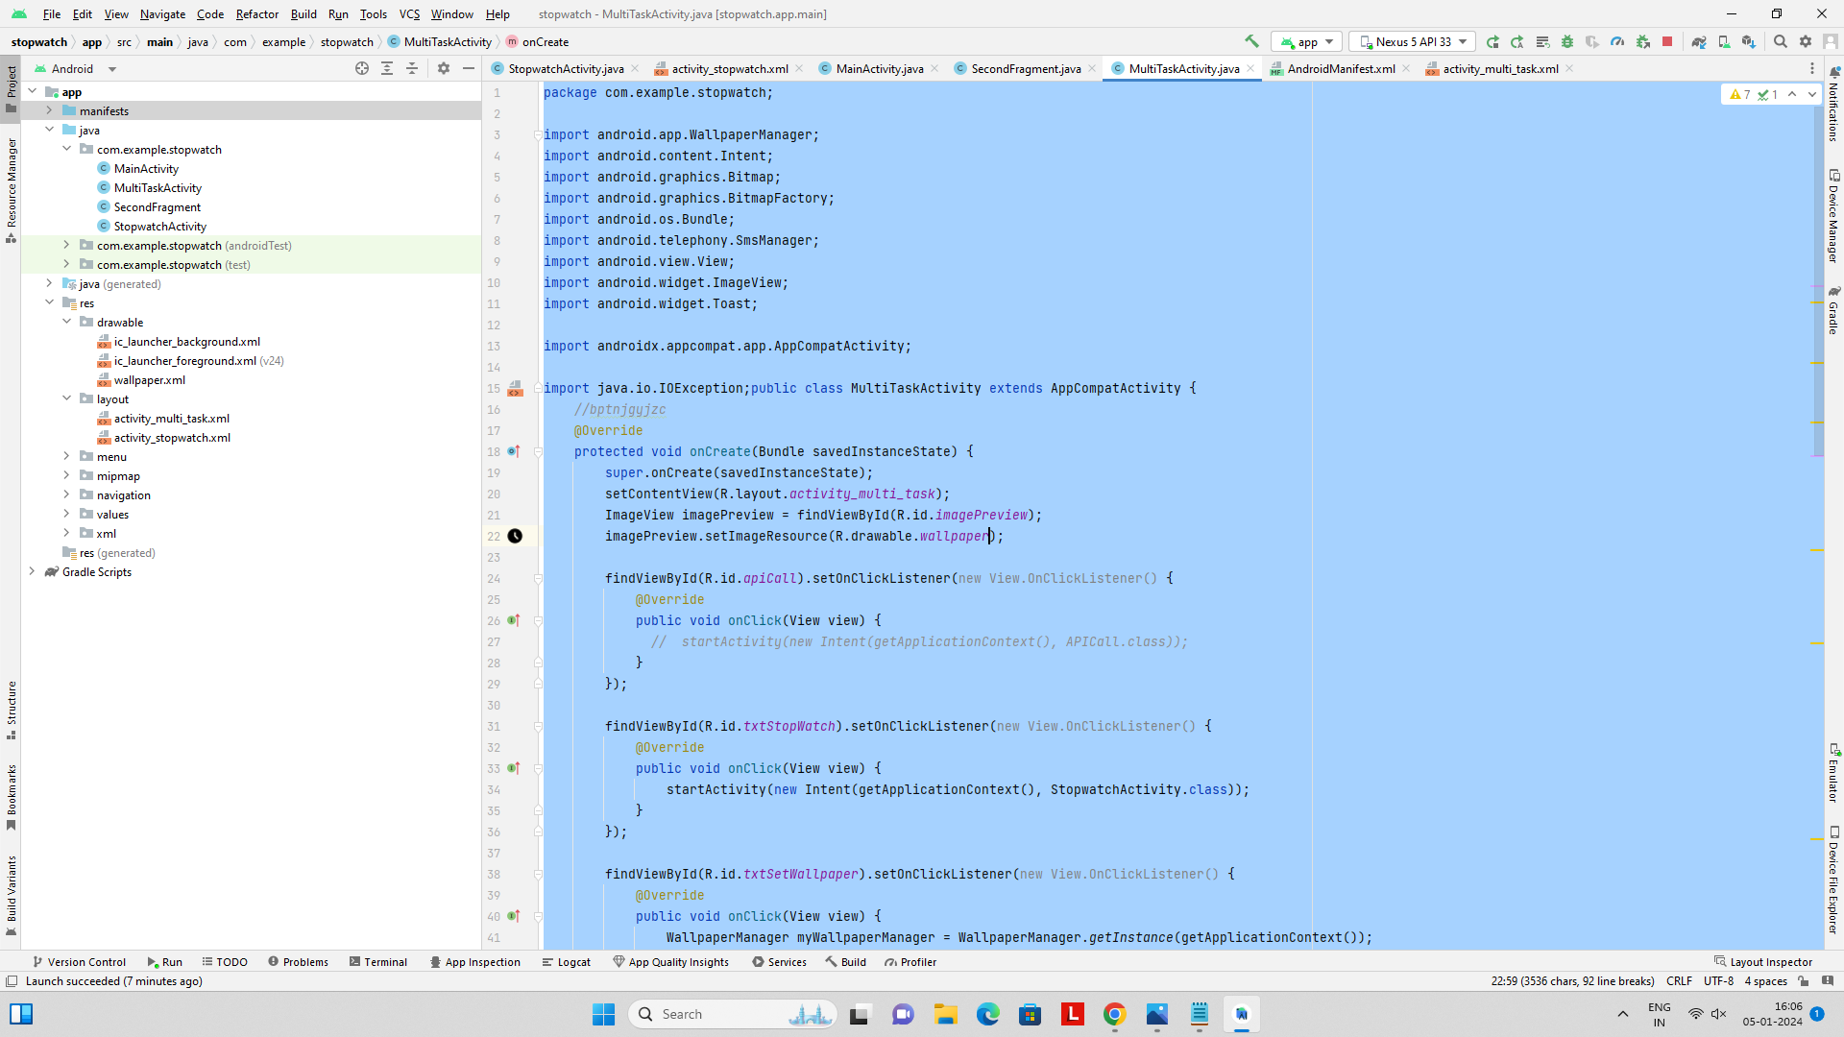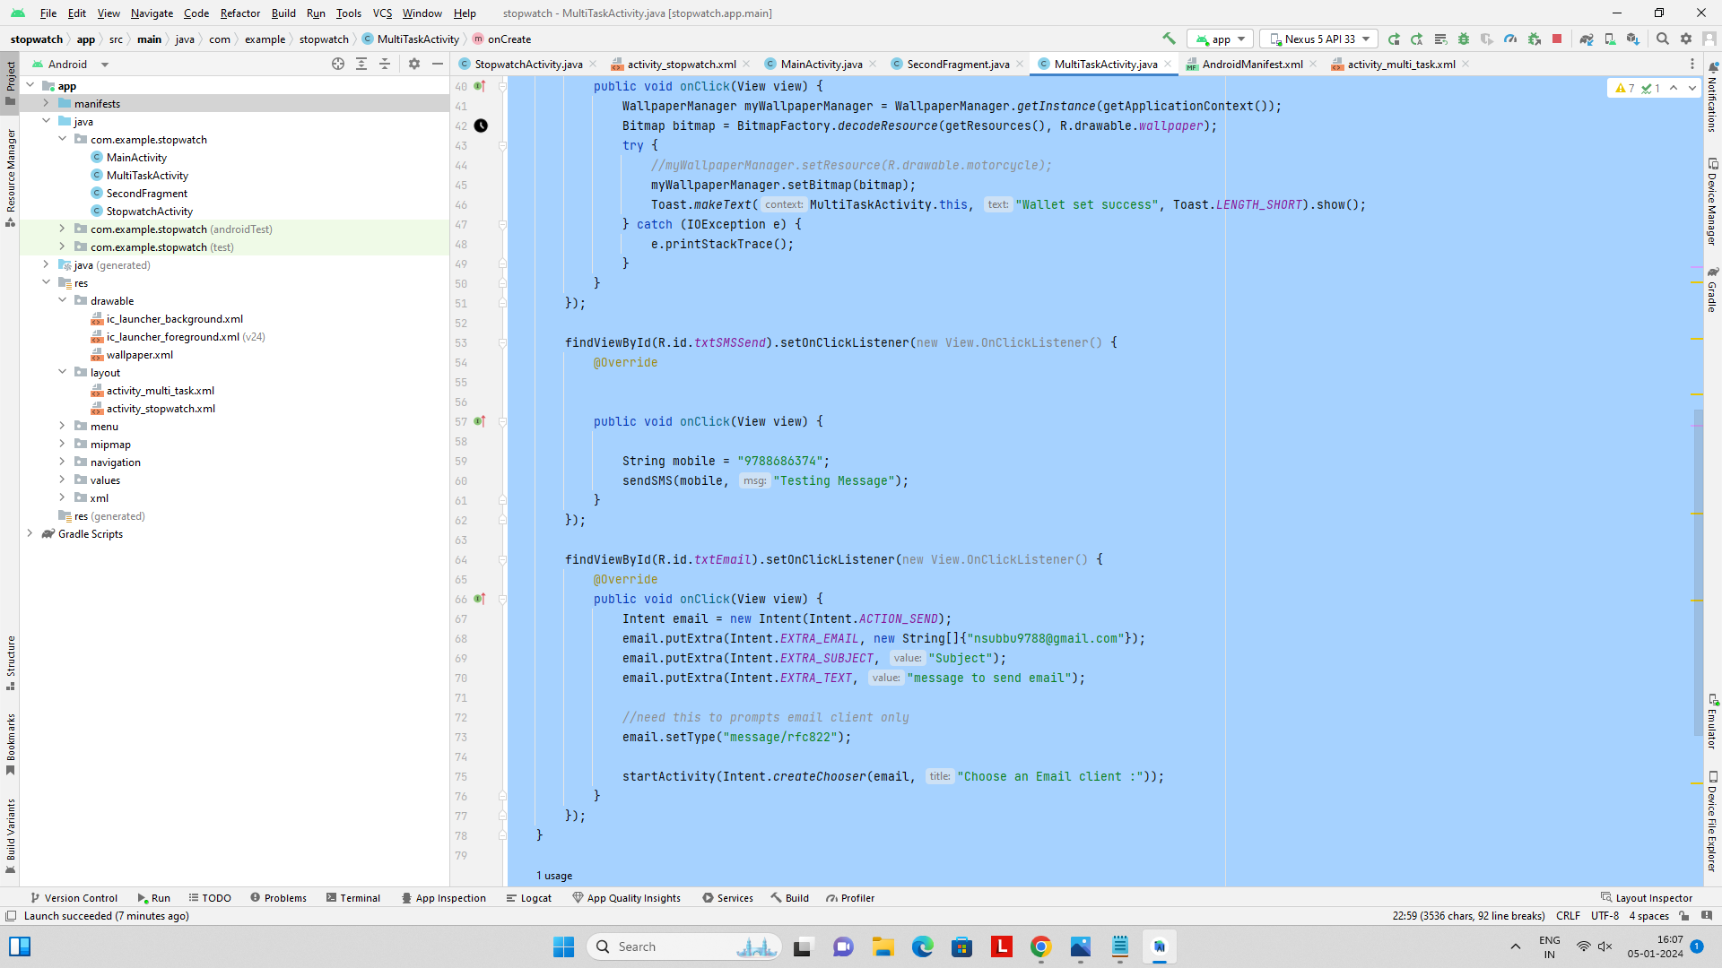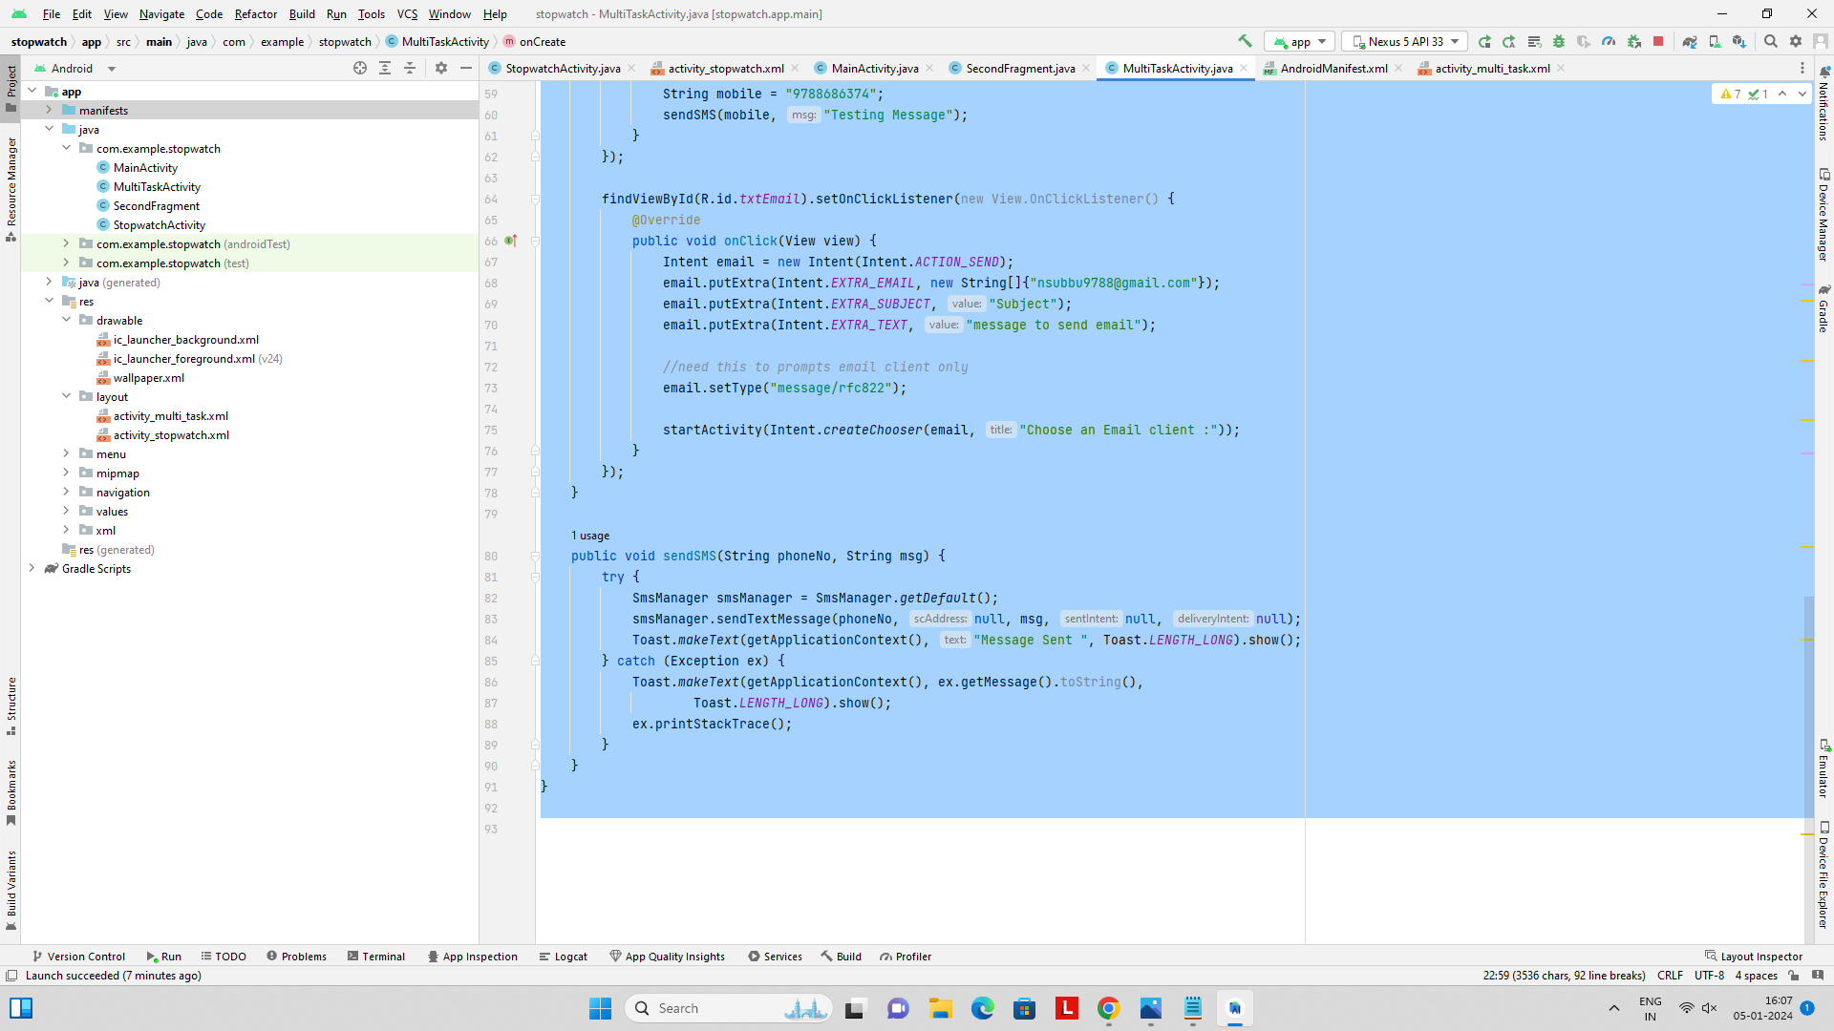

**Activity_multi_task.xml:**

***<?*xml version="1.0" encoding="utf-8"*?>***

**<LinearLayout xmlns:android="http://schemas.android.com/apk/res/android"**

**xmlns:app="http://schemas.android.com/apk/res-auto"**

**xmlns:tools="http://schemas.android.com/tools"**

**android:layout_width="match_parent"**

**android:layout_height="match_parent"**

**android:layout_gravity="center"**

**android:gravity="center"**

**android:orientation="vertical"**

**tools:context=".MultiTaskActivity">**

**<Button**

**android:id="@+id/txtStopWatch"**

**android:layout_width="wrap_content"**

**android:layout_height="wrap_content"**

**android:layout_marginTop="?actionBarSize"**

**android:text="Stop Watch"**

**app:layout_constraintEnd_toEndOf="parent"**

**app:layout_constraintStart_toStartOf="parent"**

**app:layout_constraintTop_toTopOf="parent" />**

**<ImageView**

**android:id="@+id/imagePreview"**

**android:layout_width="100dp"**

**android:layout_height="100dp"**

**android:src="@drawable/wallpaper"**

**app:layout_constraintEnd_toEndOf="parent"**

**app:layout_constraintStart_toStartOf="parent"**

**app:layout_constraintTop_toBottomOf="@id/txtStopWatch" />**

**<Button**

**android:id="@+id/txtSetWallpaper"**

**android:layout_width="wrap_content"**

**android:layout_height="wrap_content"**

**android:text="Set Wallpaper"**

**app:layout_constraintEnd_toEndOf="parent"**

**app:layout_constraintStart_toStartOf="parent"**

**app:layout_constraintTop_toBottomOf="@id/imagePreview" />**

**<Button**

**android:id="@+id/txtSMSSend"**

**android:layout_width="wrap_content"**

**android:layout_height="wrap_content"**

**android:text="Send SMS"**

**app:layout_constraintEnd_toEndOf="parent"**

**app:layout_constraintStart_toStartOf="parent"**

**app:layout_constraintTop_toBottomOf="@id/imagePreview" />**

**<Button**

**android:id="@+id/txtEmail"**

**android:layout_width="wrap_content"**

**android:layout_height="wrap_content"**

**android:text="Send Email"**

**app:layout_constraintEnd_toEndOf="parent"**

**app:layout_constraintStart_toStartOf="parent"**

**app:layout_constraintTop_toBottomOf="@id/imagePreview" />**

**<Button**

**android:id="@+id/apiCall"**

**android:layout_width="wrap_content"**

**android:layout_height="wrap_content"**

**android:text="API Calling (Web Services)"**

**app:layout_constraintEnd_toEndOf="parent"**

**app:layout_constraintStart_toStartOf="parent"**

**app:layout_constraintTop_toBottomOf="@id/imagePreview" />**

**</LinearLayout>**

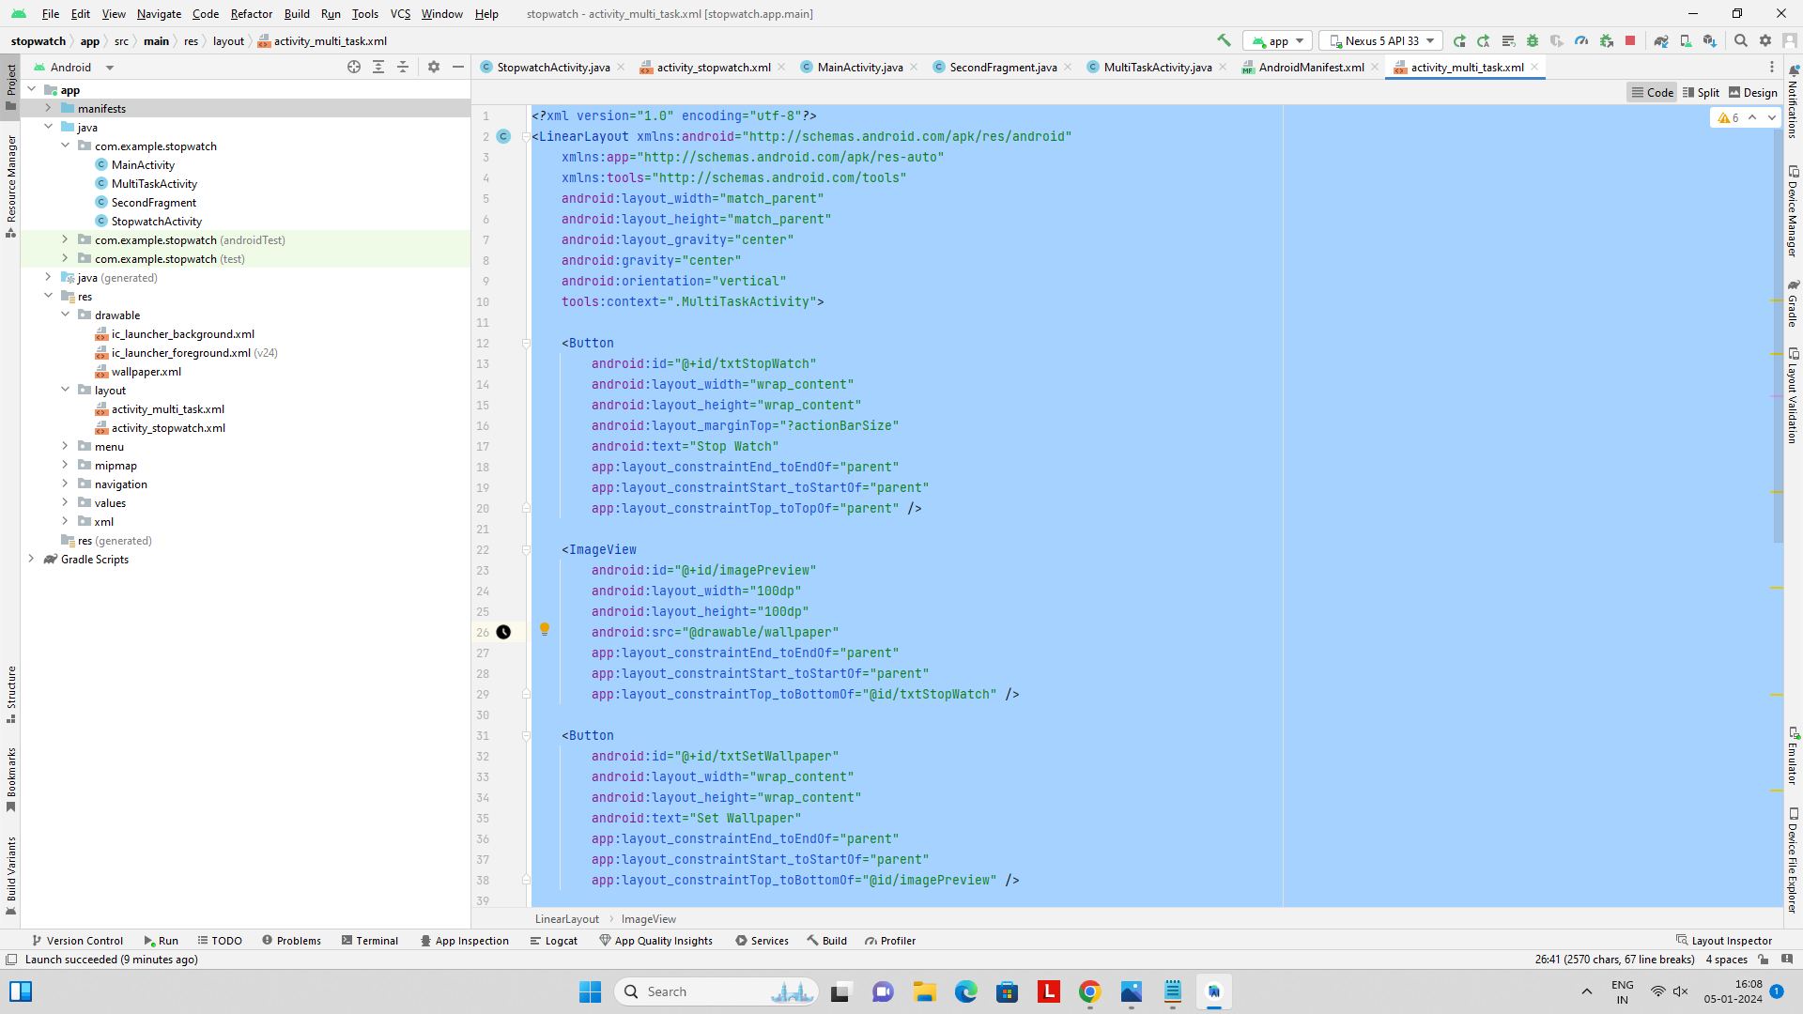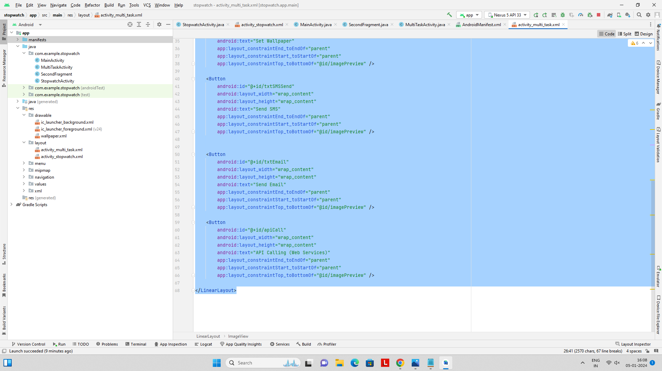

**AndroidManifests.xml:**

***<?*xml version="1.0" encoding="utf-8"*?>***

**<manifest xmlns:android="http://schemas.android.com/apk/res/android"**

**xmlns:tools="http://schemas.android.com/tools">**

**<uses-permission android:name="android.permission.SET_WALLPAPER" />**

**<application**

**android:allowBackup="true"**

**android:dataExtractionRules="@xml/data_extraction_rules"**

**android:fullBackupContent="@xml/backup_rules"**

**android:icon="@mipmap/ic_launcher"**

**android:label="@string/app_name"**

**android:supportsRtl="true"**

**android:theme="@style/Theme.Stopwatch"**

**tools:targetApi="31">**

**<activity**

**android:name=".MultiTaskActivity"**

**android:exported="true"**

**android:label="@string/app_name"**

**android:theme="@style/Theme.Stopwatch.NoActionBar">**

**<intent-filter>**

**<action android:name="android.intent.action.MAIN" />**

**<category android:name="android.intent.category.LAUNCHER" />**

**</intent-filter>**

**</activity>**

**<activity android:name=".StopwatchActivity"></activity>**

**</application>**

**</manifest>**

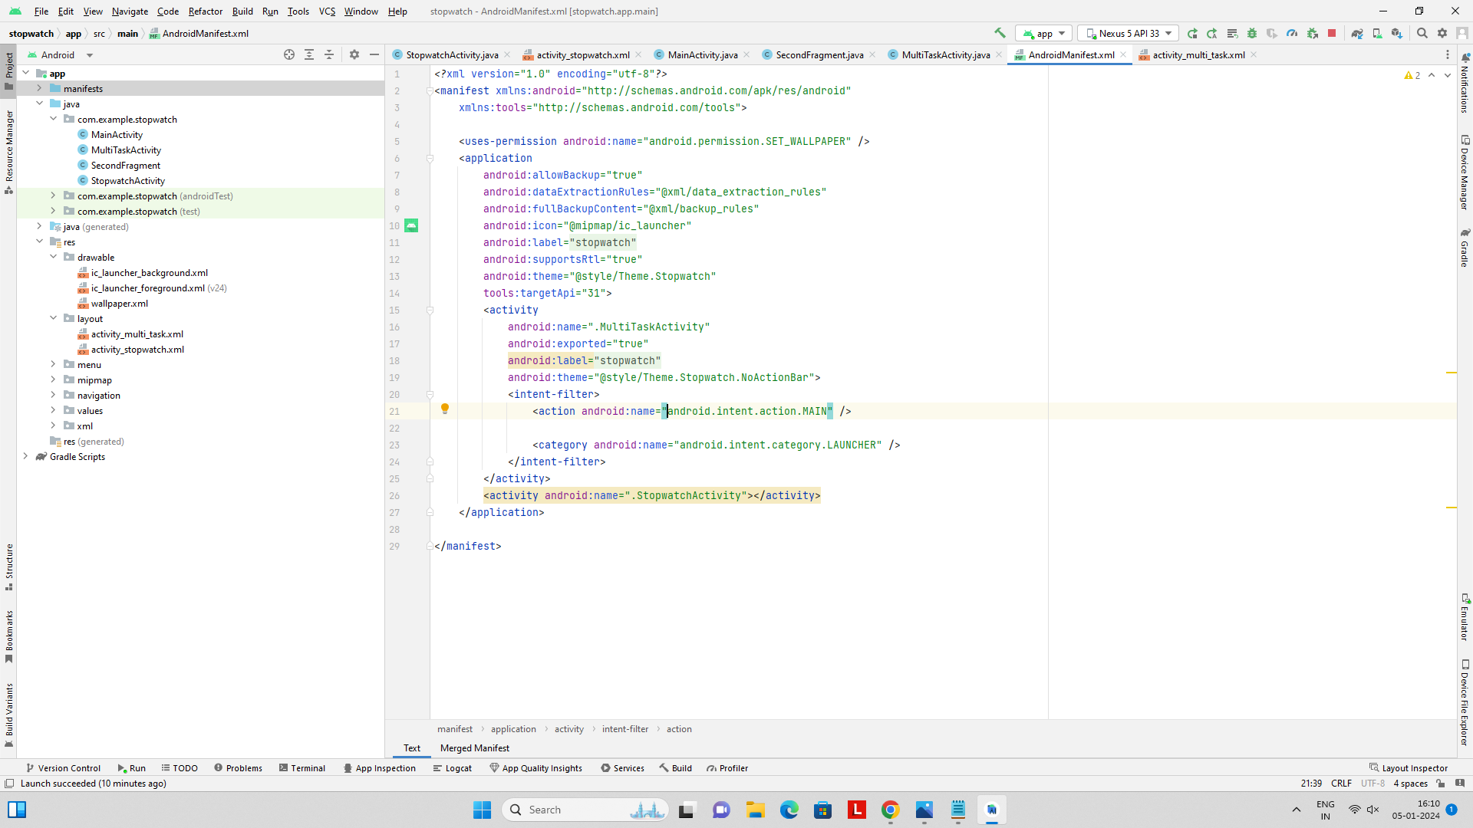

**OUTPUT:**



